7/17/2023

<https://github.com/googleCloudplatform/asl-ml-immersion>

Benoit Dherin – French/Swiss Mathematician in ML

How to write Kubeflow pipelines.

Kubeflow –

TFX – prescribed.. Needs a certain ordering. Is Rigid. Push ML models in production.

Explainable AI – why a model

Data Engineering with data flow. BEAM is open source of Map reduce framework used internally at Google.

Has various model versions – code – various ways to process the data.

Need best hyperparameters

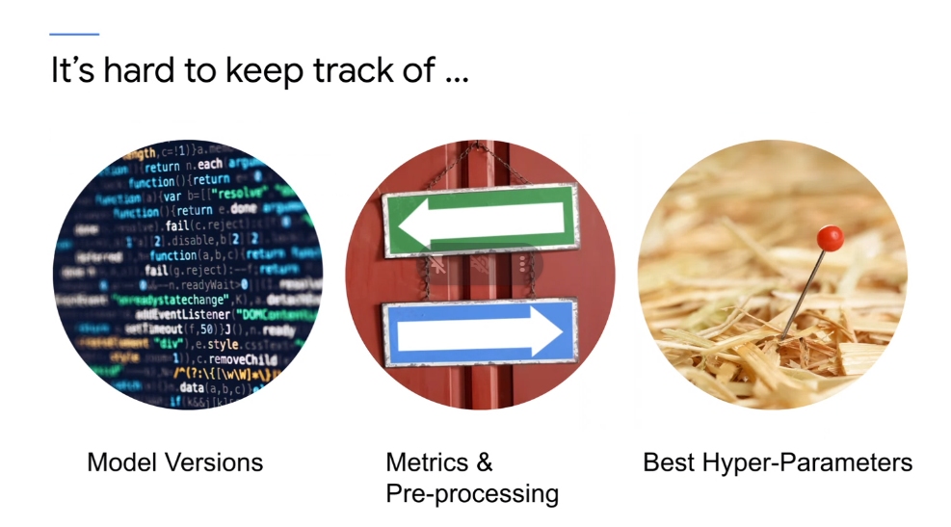

Sync all these in a canonical place. How to share the models.. .have a single place of truth – which best models to store and then reproduce the results

Have the training environment – during training phase. Trained model to run on production nodes or might been trained on own laptop.. Need infrastructure in prod.

ML Team prev – logistic regression only.. send logistic regression and send weights in prod code. Write code on physical server and then send to prod.. ouch! No MLOPS in that company.

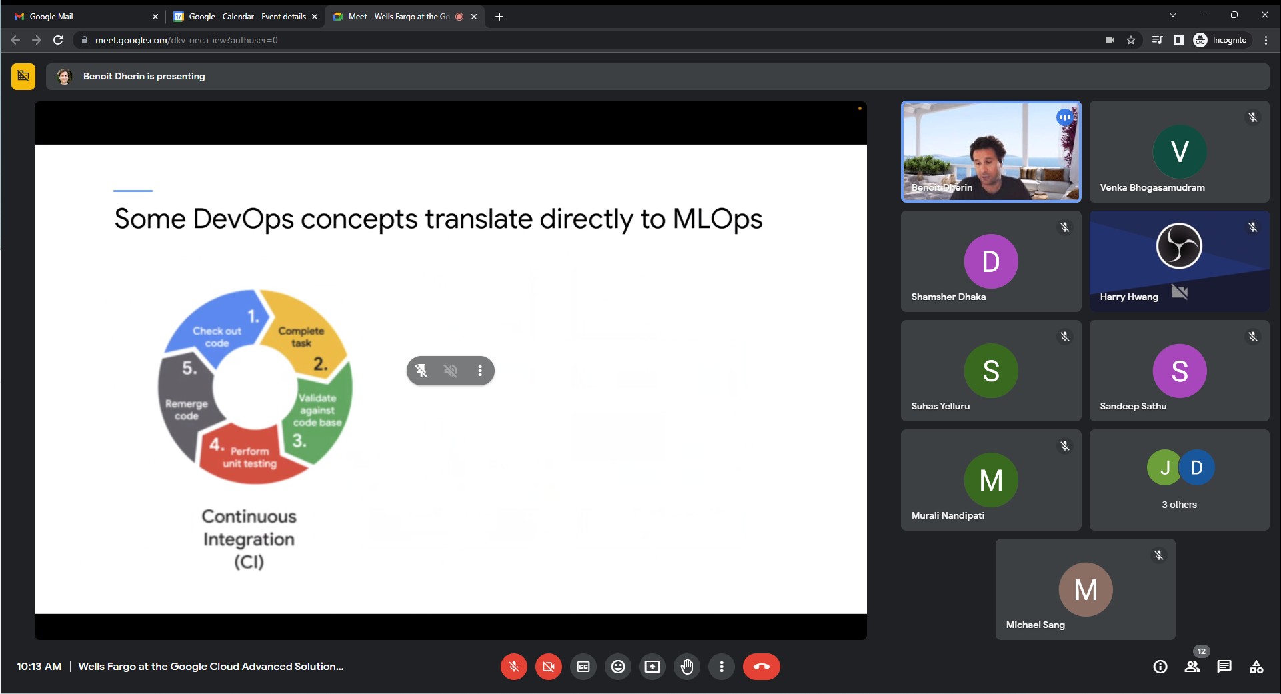

CI/CD – Build/compile.

MLOPS – continuous training. Data changing over time.. covid, fin model algo predicting stock prices may not be valid.

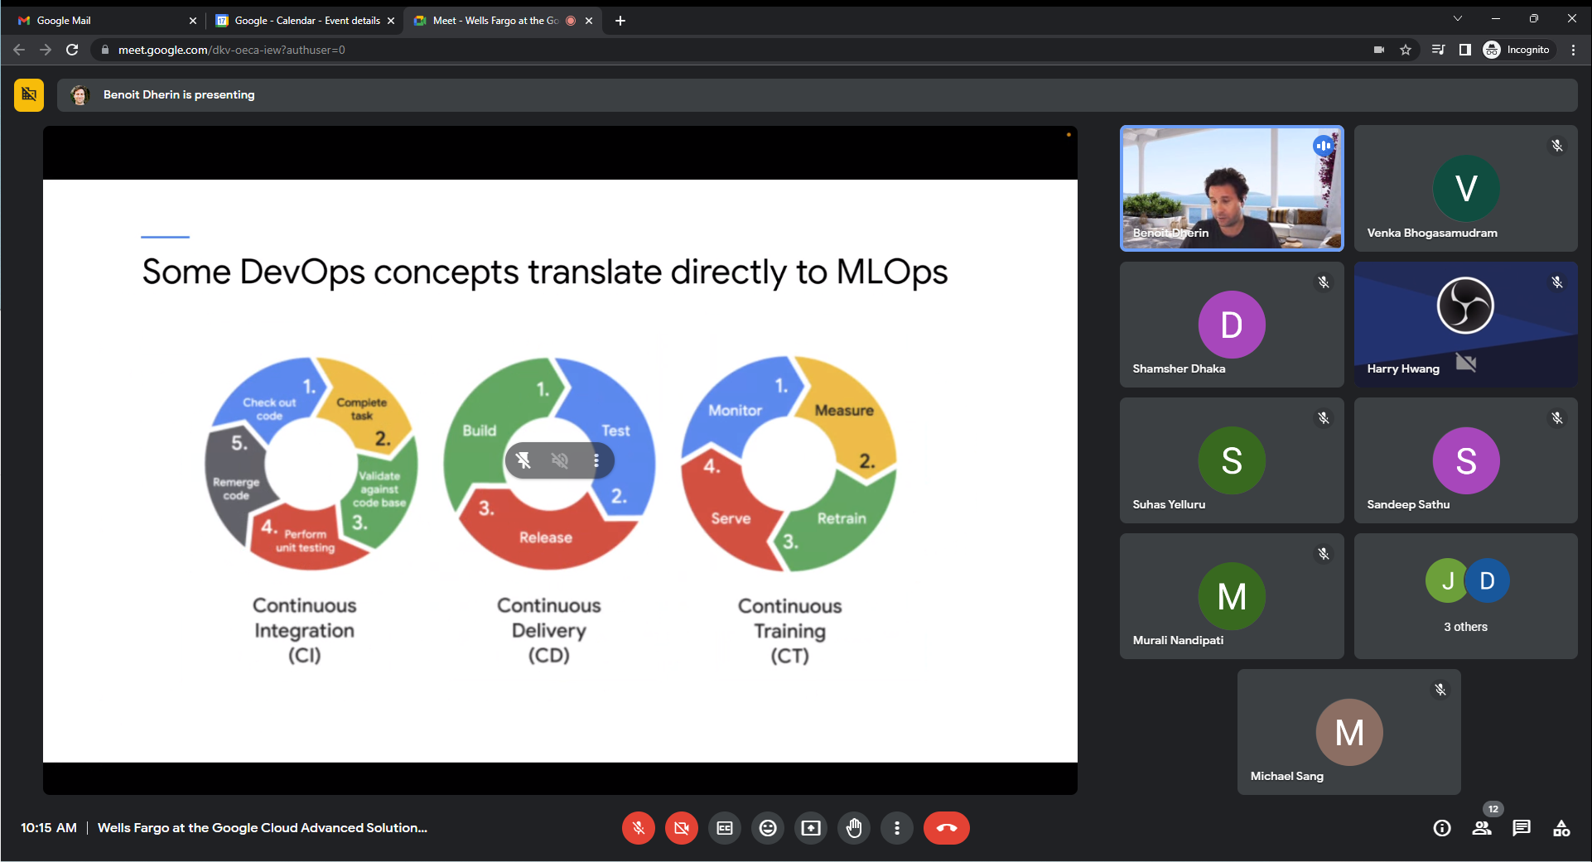

Process what ML model is doing and if some threshold not satisfied, retrain.

MLOPS – is devops + CT/Monitoring.

ML – can only measure performance of system as a whole – and not single

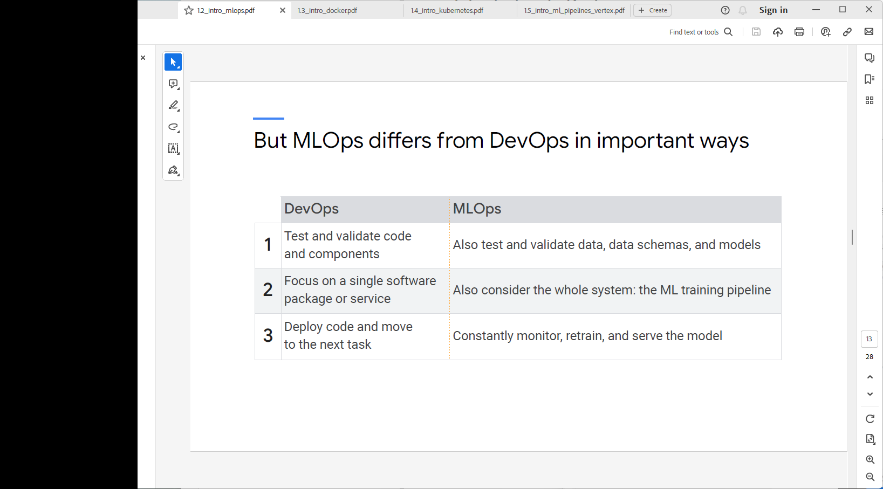

Constantly monitor, retrain and serve model.

ML – needs many iterations – change preprocessing if not work.

Containerized – since deployment complexity.

Model Decay – recommendation model. Measure model, retrain it on new data on scheduled basis.

ML Pipelines in MLOPS.

Unit Tests for ML Models --

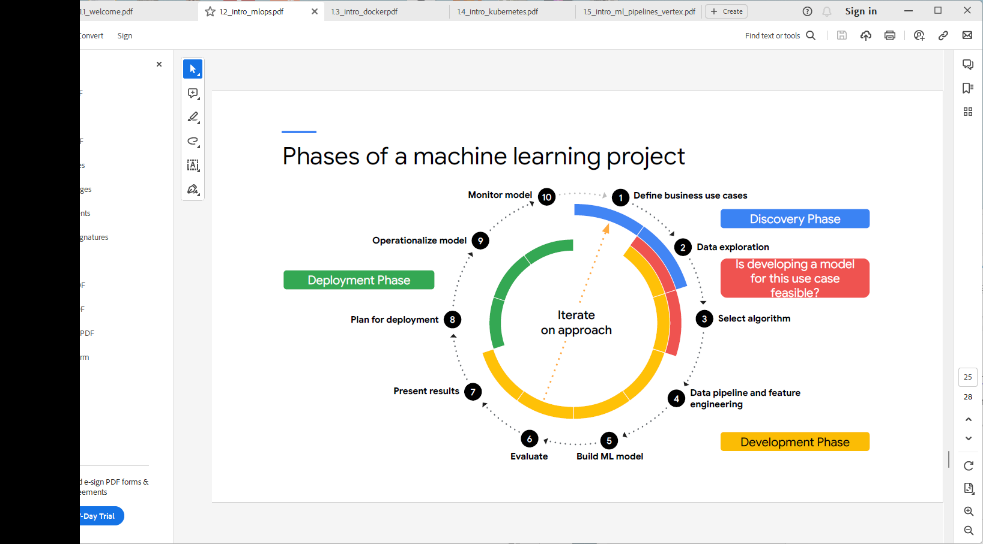

ML Pipeline –

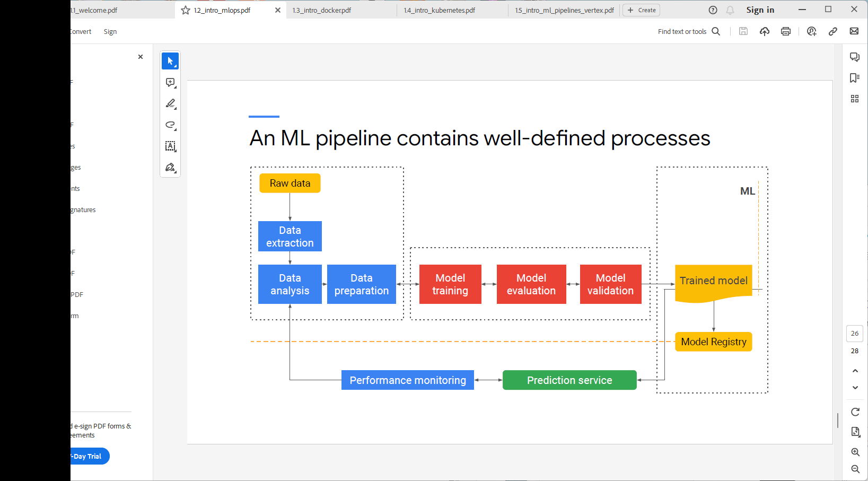

No anomalies in Raw data.

Trained model that passed all checks and put them into model registry – as an API or batch job.

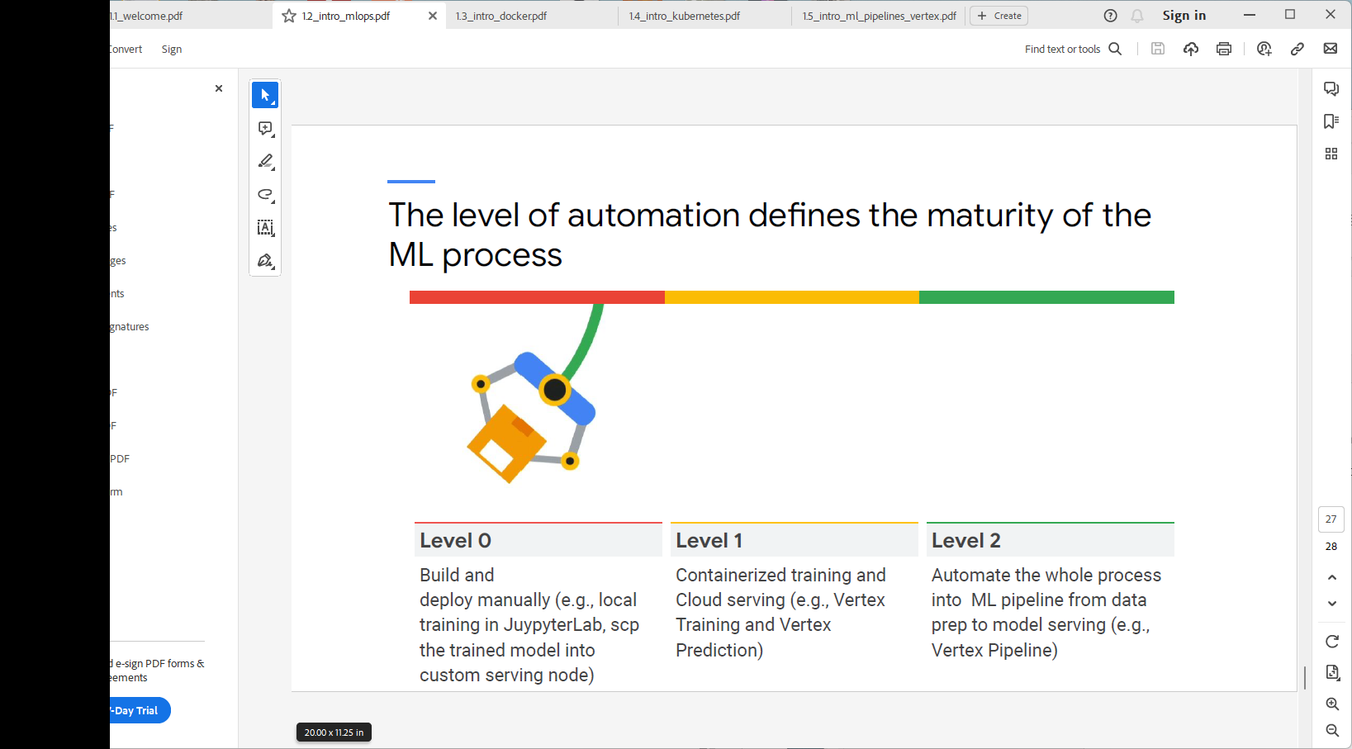

Code is python package can serialize on github code repo.

ML engineer – extract the data.

Level 2 = Just have a manual trigger to do data extraction, model training, model push

Level 0 – use small data to be fast

Level 1 – need infrastructure and do containerized training. When good perf and have infrastructure, then go to level 2.

Introduction to Docker --- as soon as leaving level 0, then need CONTAINERS!

What is Docker?

Platform for developing, shipping and running apps.

Container will have all libs to run code.

Hypervisor – slow. Docker makes translation directly – much less to emulate/generate and much faster to create the containers.

Within VM, have containers

Docker – has VM’s? – no Use case. That perhaps does NOT EXIST!

Have VM then have the containers.

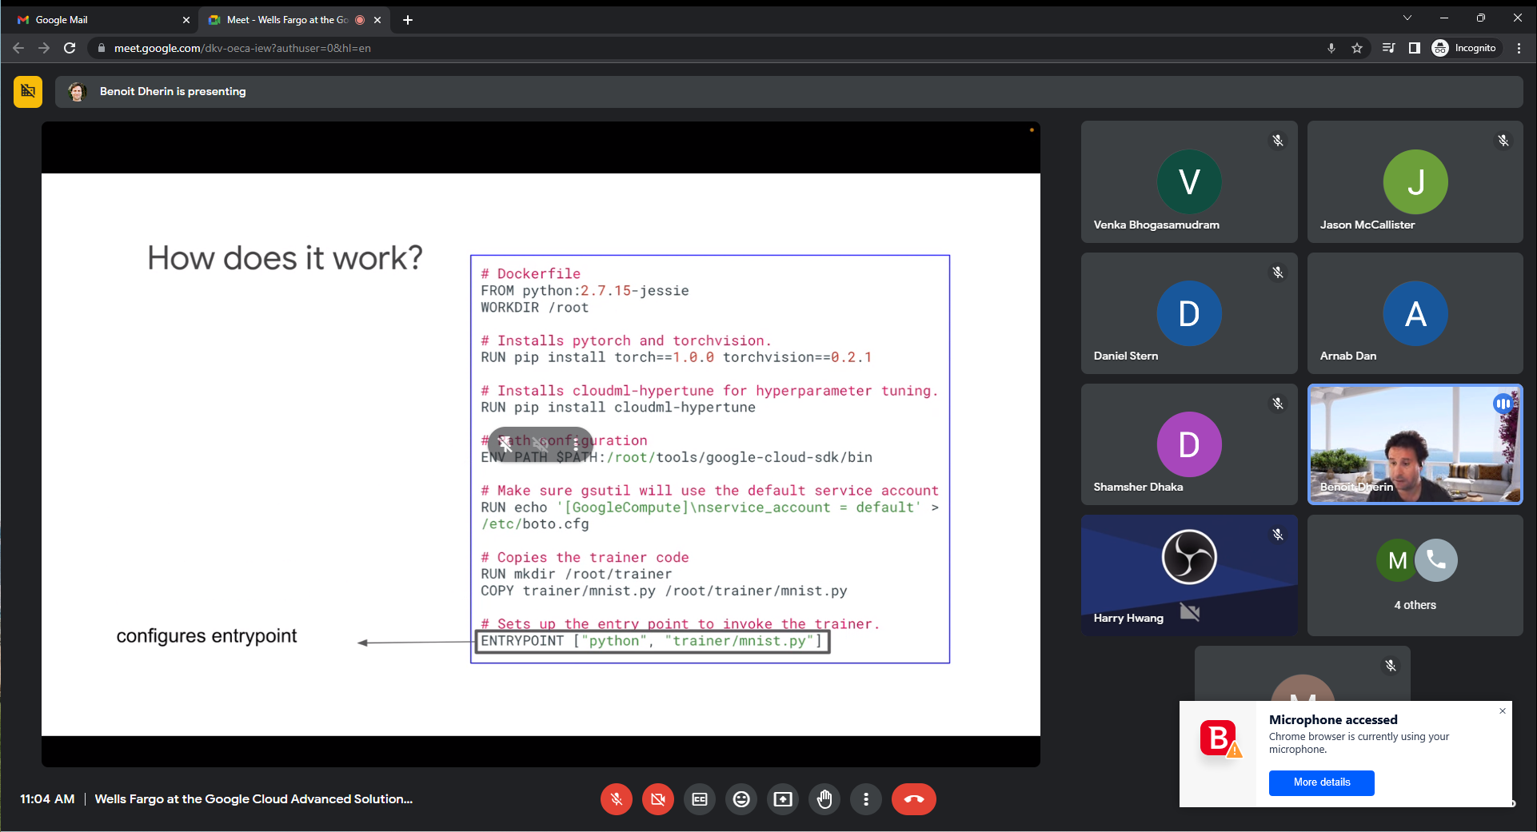

Docker build -t $IMAGE_NAME

Docker – is a full node/os – has a number of ports..

Docker run -p 4000:80 $IMAGE_NAME -- maps port 80 to port 4000 where you’re programming locally. Port 4000 on local machine. 80 is port in docker container.

Docker – has no IP Address!! Localhost has no ipaddress only localhost but has ports..

Docker – is within VM

Container has own file system, can create directories. It’s like a HD.

Export port in container

**gcr.io** is a domain used by Google Cloud Platform (GCP) for its Container Registry service. Container Registry is a private and secure storage system for Docker container images. **gcr.io** is the hostname that represents the Google Cloud Container Registry.

The Container Registry allows you to store, manage, and deploy your container images in a scalable and reliable manner. It integrates well with other GCP services such as Google Kubernetes Engine (GKE), Cloud Run, and Cloud Functions, enabling you to easily deploy and run containerized applications.

When you push your Docker container images to the Container Registry, they are stored in a Google Cloud Storage bucket with the **gcr.io** domain as the registry URL. The **gcr.io** registry URL is structured as follows:

phpCopy code

gcr.io/<project_id>/<image_name>

Here, **<project_id>** refers to your GCP project ID, and **<image_name>** is the name you choose for your container image.

For example, if your GCP project ID is **my-project** and you have an image named **my-image**, the full container image reference in the Container Registry would be:

perlCopy code

gcr.io/my-project/my-image

You can then use this reference to pull and deploy your container image in various GCP services that support containerization.

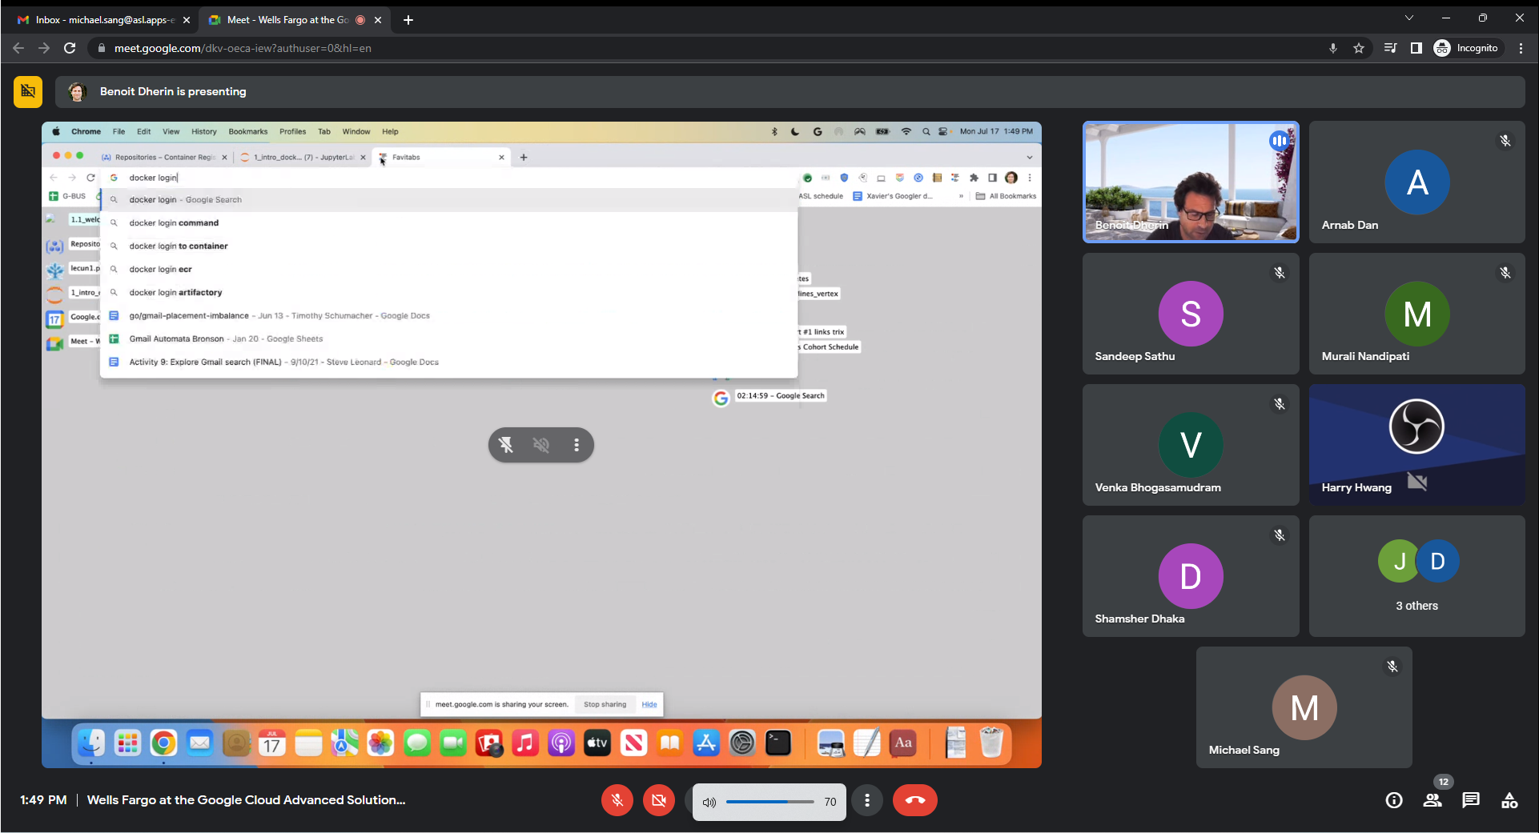

./app is File system of Docker container… not from jupyter lab.

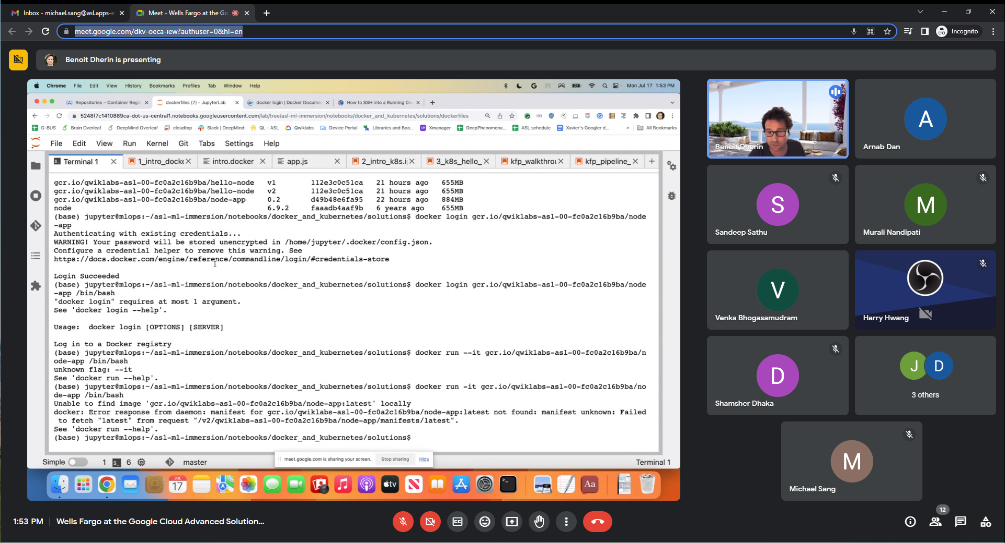

How to login into a Docker Container?

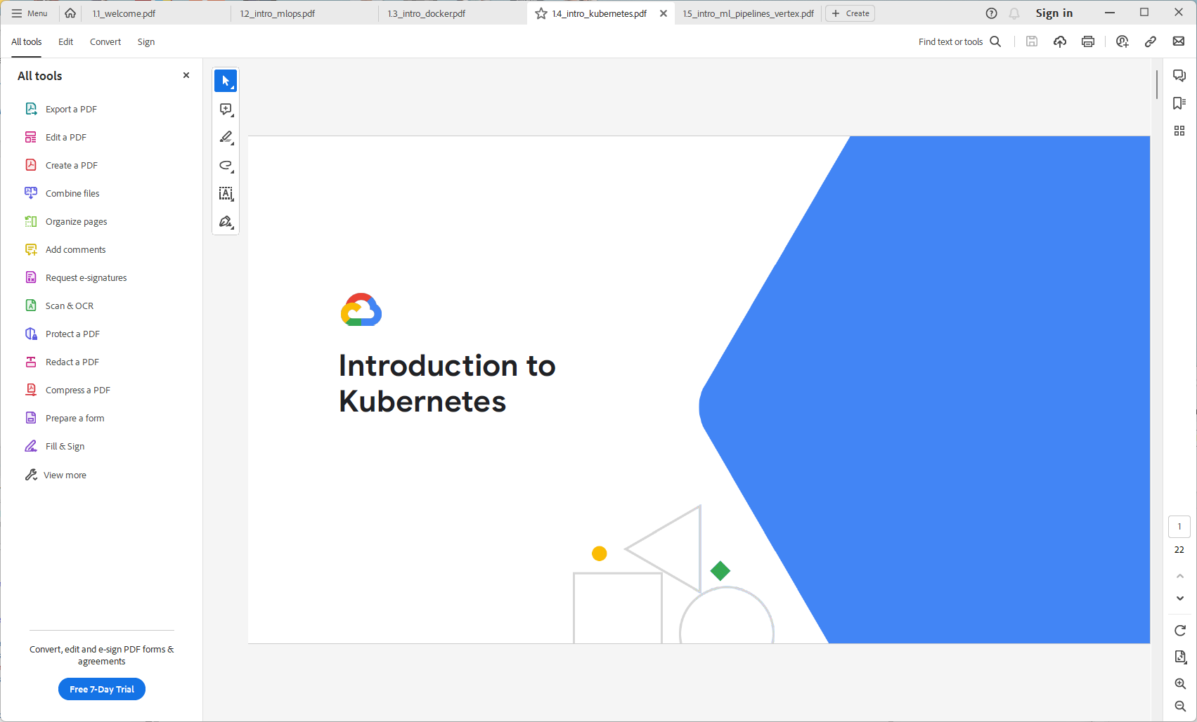

Kubernetes – platform to work with containers… (E.g. Docker containers).

Docker – can package code into docker container and run where you have a docker engine.

Bunch of servers – gets compliated to scale. Adding a server to a pool of servers.

Manage all compute efficiently.

Software to know which containers running on which server…

How Kubernetes works?

Kubernetes master keeps track of how much resources are in use.. RAM, CPU, GPU, Bandwidth

Kubernetes – add load balancer and do scaling.

Kubernetes bundle together several apps – Has a Service to group together several apps as a single Service.

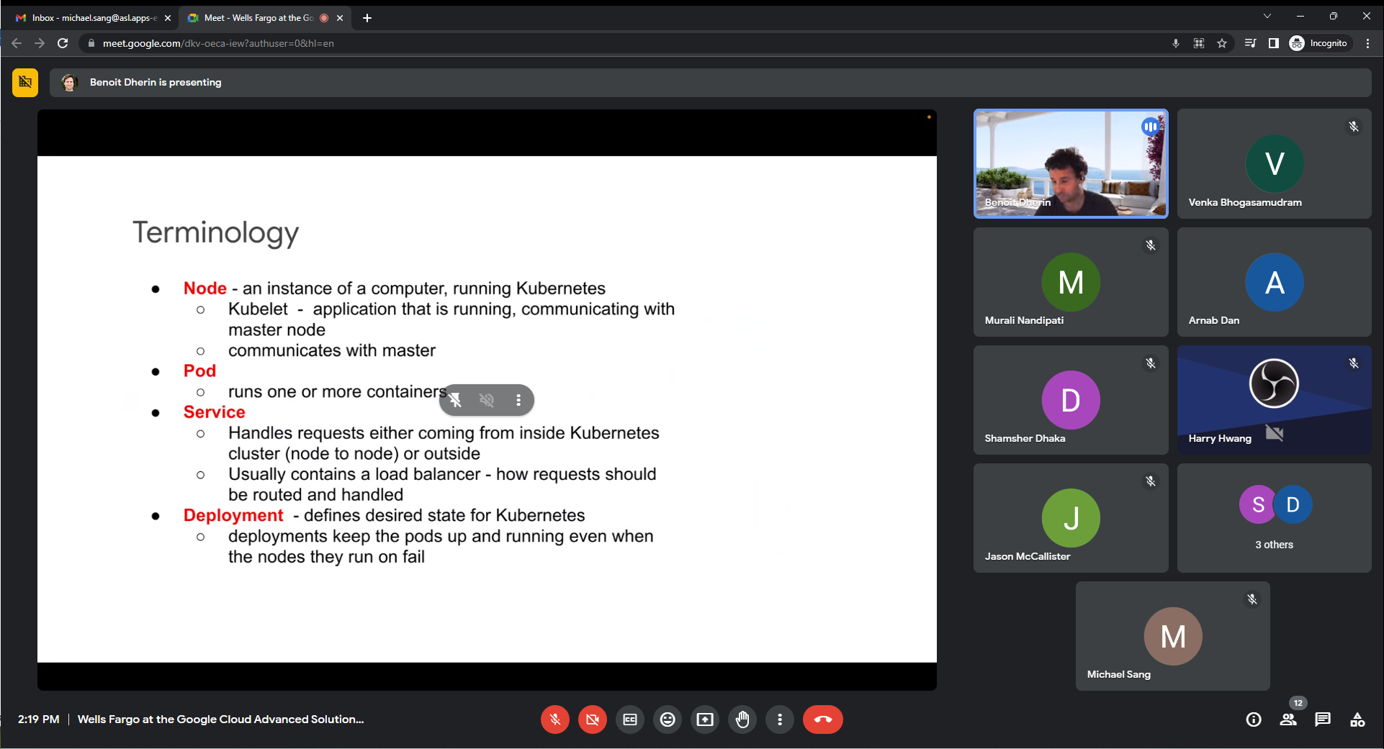

Kubelet – app running communicates with master node.

Have a POD – think of it as a virtual machine on which run several containers, and makes it very easy to communicate. POD as a VM running one or more containers…

Load bal balances requests among several pods.

Kubernetes can know one pod missing. Deployment to keep the pods up and running.

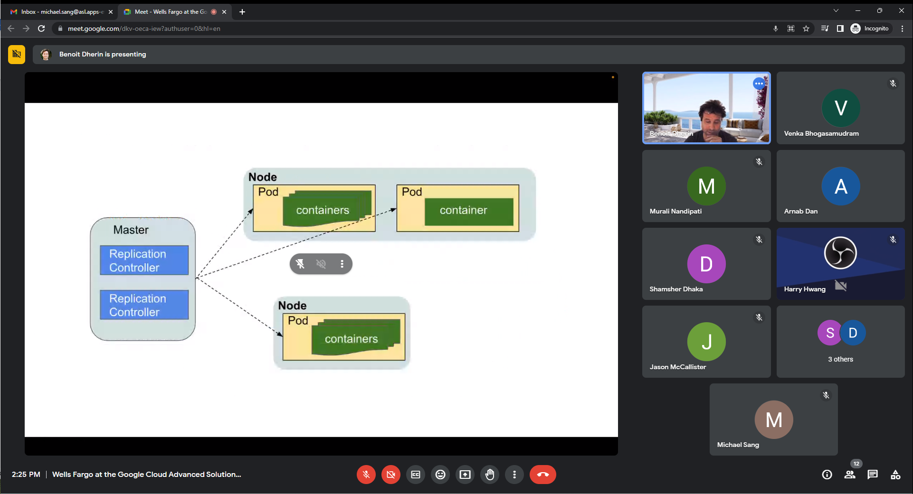

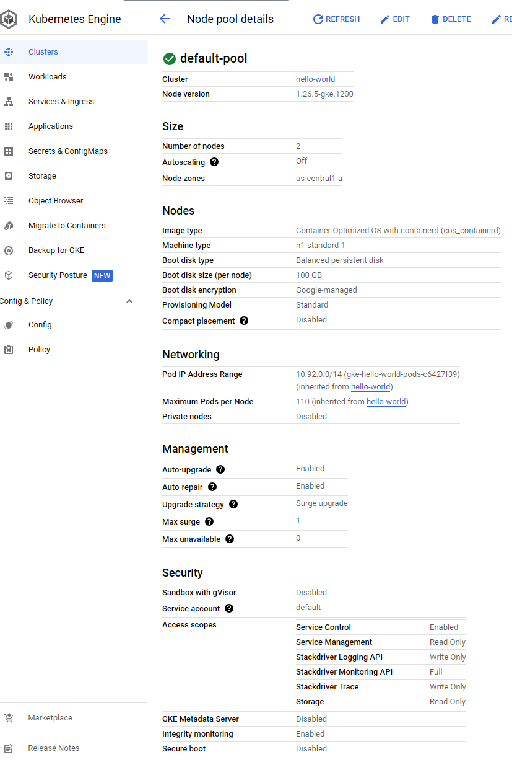

Node containing several Pods. Each Pod (as a VM running one or more containers).

Benoit Dherin

2:41 PM

Thanks Venka, Shamsher, and Murali. This is correct. To login into a running container

docker exec -it <container ID/name> /bin/bash

If you also want to log into a image that is not run, you'll have to do:

docker run -it <image ID/name> /bin/bash

Kubernetes Lab#1:

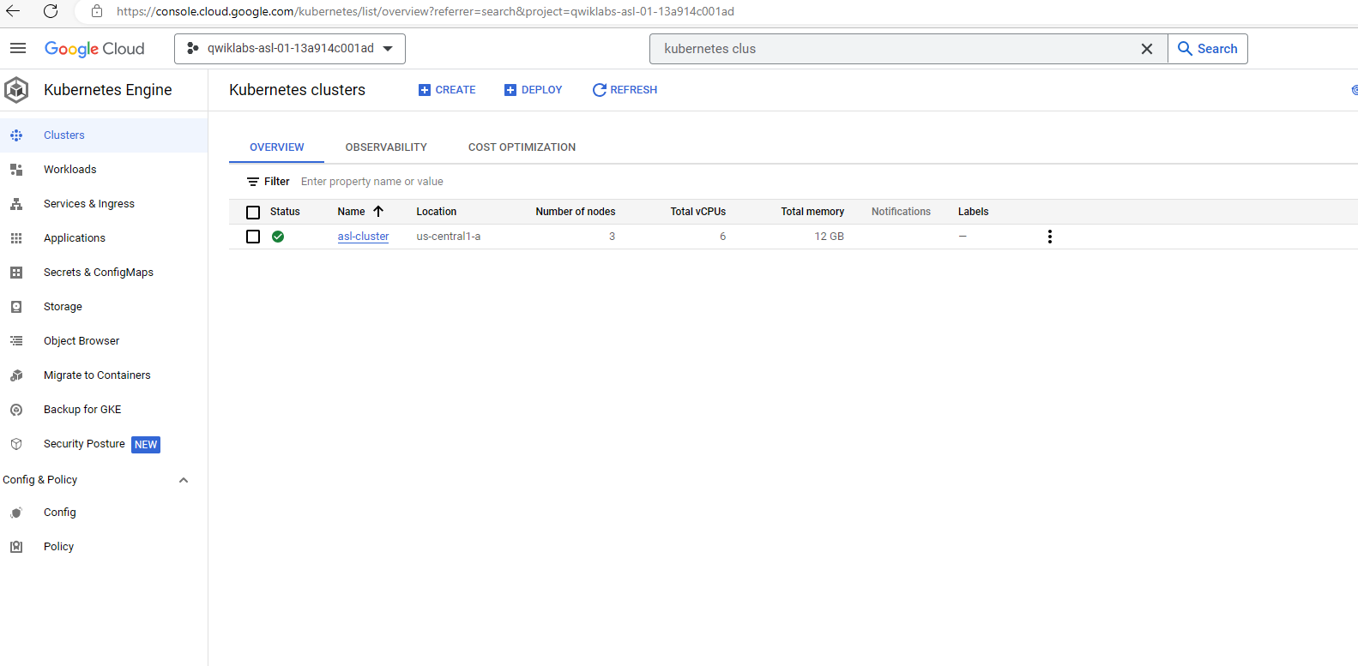

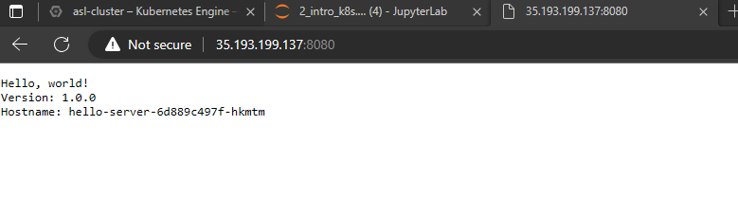

* docker exec -it <container> /bin/bash
* docker run -it <image> /bin/bash
* (base) jupyter@mlops:~/asl-ml-immersion/notebooks/docker_and_kubernetes/labs$ docker images

REPOSITORY TAG IMAGE ID CREATED SIZE

gcr.io/qwiklabs-asl-01-13a914c001ad/hello-node v2 2b79bfd152b0 38 minutes ago 655MB

gcr.io/qwiklabs-asl-01-13a914c001ad/hello-node v1 98e3f4af3dae 58 minutes ago 655MB

gcr.io/qwiklabs-asl-01-13a914c001ad/node-app 0.2 d274375d736d 5 hours ago 884MB

node 6.9.2 faaadb4aaf9b 6 years ago 655MB

(base) jupyter@mlops:~/asl-ml-immersion/notebooks/docker_and_kubernetes/labs$ docker run -it gcr.io/qwiklabs-asl-01-13a914c001ad/hello-node:v2 /bin/bash

root@5711afd0985b:/#

root@5711afd0985b:/# ls

bin boot dev etc home lib lib64 media mnt opt proc root run sbin server.js srv sys tmp usr var

root@5711afd0985b:/#

*The command docker run -it gcr.io/qwiklabs-asl-01-13a914c001ad/hello-node:v2 /bin/bash does the following:*

1. *It pulls the Docker image gcr.io/qwiklabs-asl-01-13a914c001ad/hello-node:v2 from the Google Container Registry (GCR).*
2. *It creates a new Docker container from the image.*
3. *It attaches the standard input, output, and error streams (stdin, stdout, stderr) of the container to the corresponding streams of the current shell.*
4. *It opens a bash shell in the container.*

*The -it option tells Docker to create a interactive container, which means that you can interact with the container's shell. The /bin/bash option tells Docker to run the bash shell in the container.*

*The full command can be broken down into the following parts:*

* *docker run is the command to run a Docker container.*
* *-it is the option to create an interactive container.*
* *gcr.io/qwiklabs-asl-01-13a914c001ad/hello-node:v2 is the name of the Docker image to pull and run.*
* */bin/bash is the command to run in the container.*

*If you run this command, you will be dropped into a bash shell inside the Docker container. You can then interact with the container's filesystem and run commands.*

*For example, you could run the following command to list the files in the container's current directory:*

*ls*

* (base) jupyter@mlops:~/asl-ml-immersion/notebooks/docker_and_kubernetes/labs/dockerfiles$ docker ps

CONTAINER ID IMAGE COMMAND CREATED STATUS PORTS NAMES

5711afd0985b gcr.io/qwiklabs-asl-01-13a914c001ad/hello-node:v2 "/bin/bash" About a minute ago Up About a minute 8000/tcp nervous_hertz

992a7772cc63 gcr.io/qwiklabs-asl-01-13a914c001ad/node-app:0.2 "node ./src/app.js" 4 hours ago Up 4 hours 0.0.0.0:4000->80/tcp, :::4000->80/tcp elastic_boyd

(base) jupyter@mlops:~/asl-ml-immersion/notebooks/docker_and_kubernetes/labs/dockerfiles$ docker exec -it 5711afd0985b /bin/bash

root@5711afd0985b:/#

*The main difference between the two commands is that docker run creates a new container, while docker exec attaches to an existing container.*

*The docker run command takes a Docker image as input and creates a new container from that image. The container is then started and the command specified by the command option is run.*

*The docker exec command takes a running container as input and attaches to it. The standard input, output, and error streams of the container are then attached to the corresponding streams of the current shell. This allows you to interact with the container's shell as if it were a local shell.*

*In other words, docker run creates a new container and starts it, while docker exec attaches to an existing container and allows you to interact with it.*

*Here is a table that summarizes the key differences between the two commands:*

|  |  |
| --- | --- |
| *Command* | *Description* |
| *docker run* | *Creates a new container and starts it.* |
| *docker exec* | *Attaches to an existing container and allows you to interact with it.* |

*drive_spreadsheetExport to Sheets*

*Here are some examples of how the two commands can be used:*

*# Create a new container and start it.*

*docker run -it ubuntu bash*

*# Attach to an existing container and interact with it.*

*docker exec -it 5711afd0985b bash*

**REVIEW of LAB #2: Kubernetes**

Kubernetes cluster running behind a service.

Expose your deployment. Kub then creates a service with that external IP address to connect to.

----- END OF MONDAY CLASS 7/17/2023

7/18/2023

Docker containers – package all the image, compile universal binary to run on any platform.

Run anywhere we have docker engine or Kubernetes.

Machine Learning pipelines – today. A bit like docker image but not only for training code.. also training step, evaluation step.. All encapsulate in a SINGLE ARTIFACT so that anywhere we have Kubeflow running then can start.

Standard, robust manner on GCP –

Also automate the whole workflow: dataprep, training, serving, evaluation in a single pipeline. Learn to do that using Kubeflow. All components nicely package into a Docker container which makes it reusable.

<https://github.com/GoogleCloudPlatform/asl-ml-immersion>

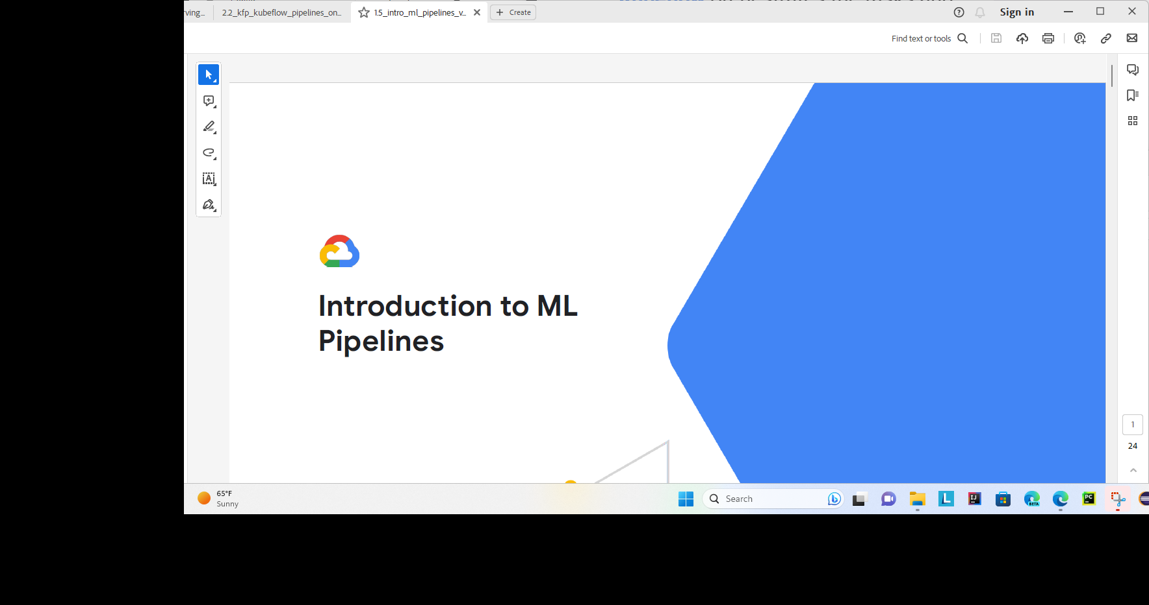

Training model – run a container

Deploy model – run a container

Have a DAG (directed acyclic graph) of dependencies with several Docker containers.

ML workflow – training, tuning, deployment

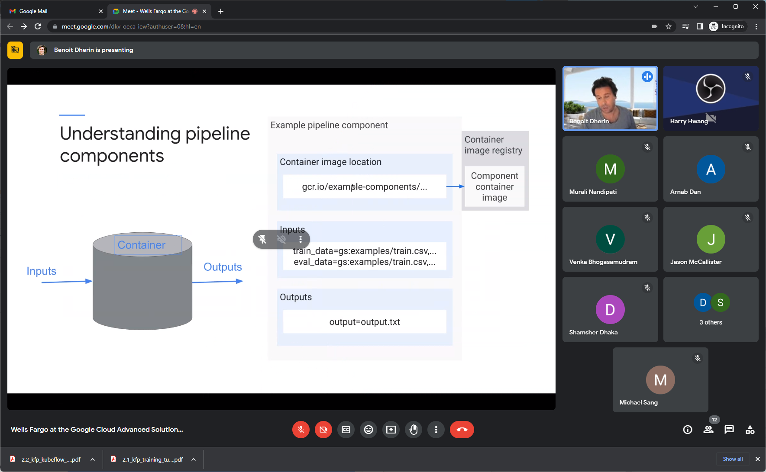

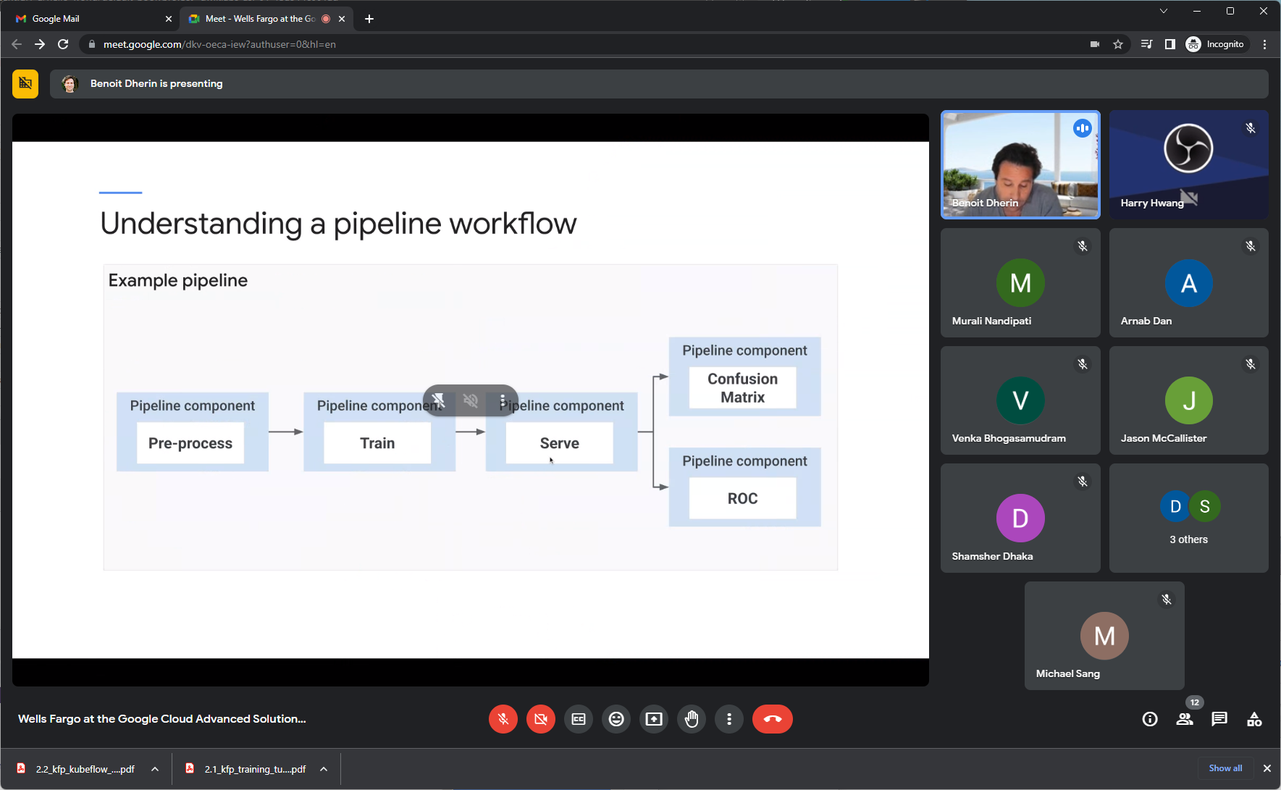

ROC – measure of classifier of performance for Binary classification.

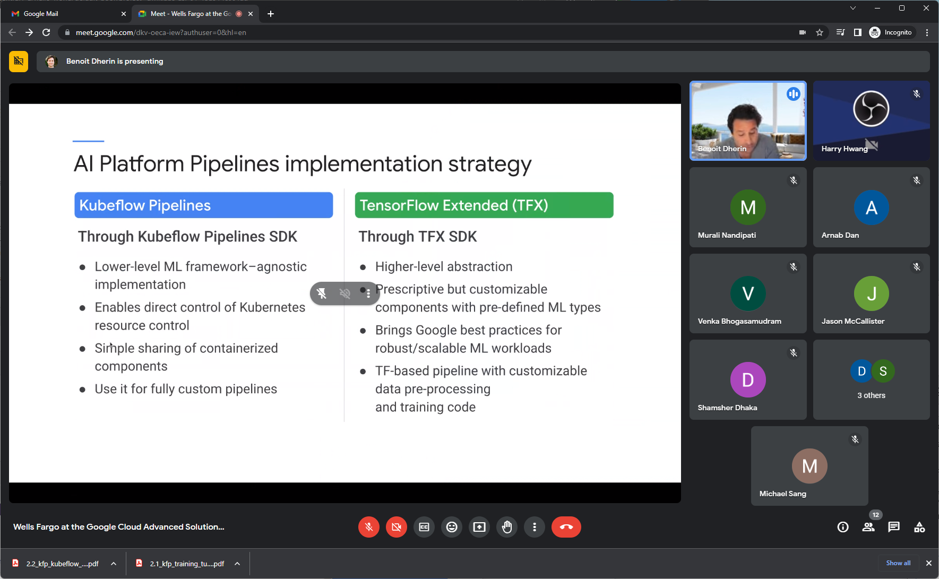

KFP – Use them independently of the pipeline.

TFX – components written for you. Can use them or not. They are run in a certain order encapsulating Google scalability.

Using sci-kit learn – not for TFX.

Monitor data distribution like in google – data changing quick use TFX. IF data changing quickly, then KFP needs to update also quickly.

Vertex pipeline – is KFP pipeline

KFP – model garden starting

KFP and TFX all running on Kubernetes?

Below TFX pipeline running on KFP:

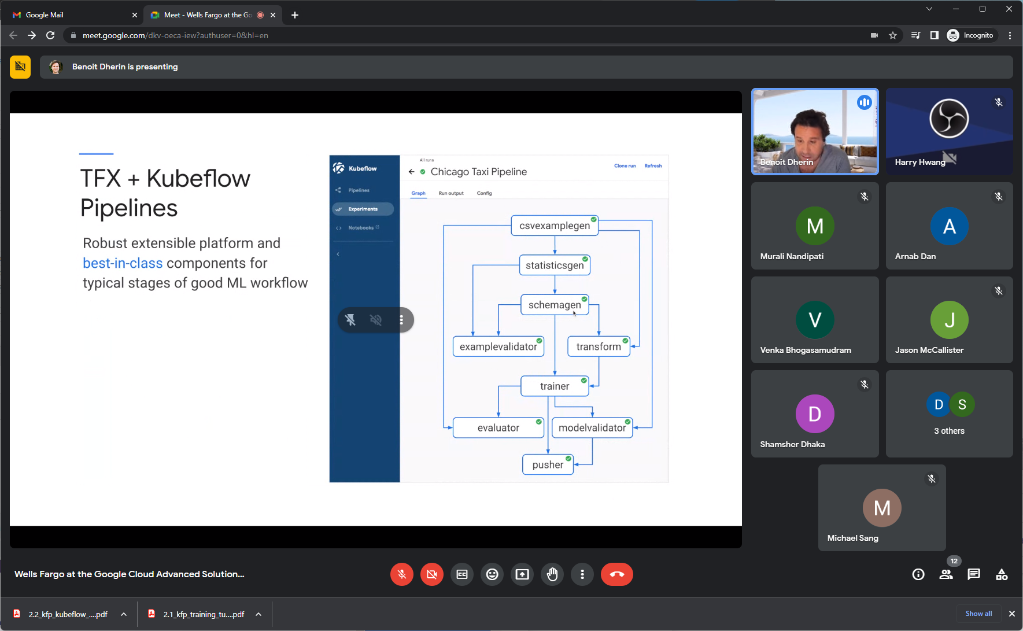

TFX – can create custom component also… but not that good.. Instead use KFP pipeline when creating custom components.

With TFX – writing tfx pipeline. Each component can use TFX sdk.

TFX – mostly scaffolding. Not a lot of code to be written.

Serialize artifact and upload to pipeline..

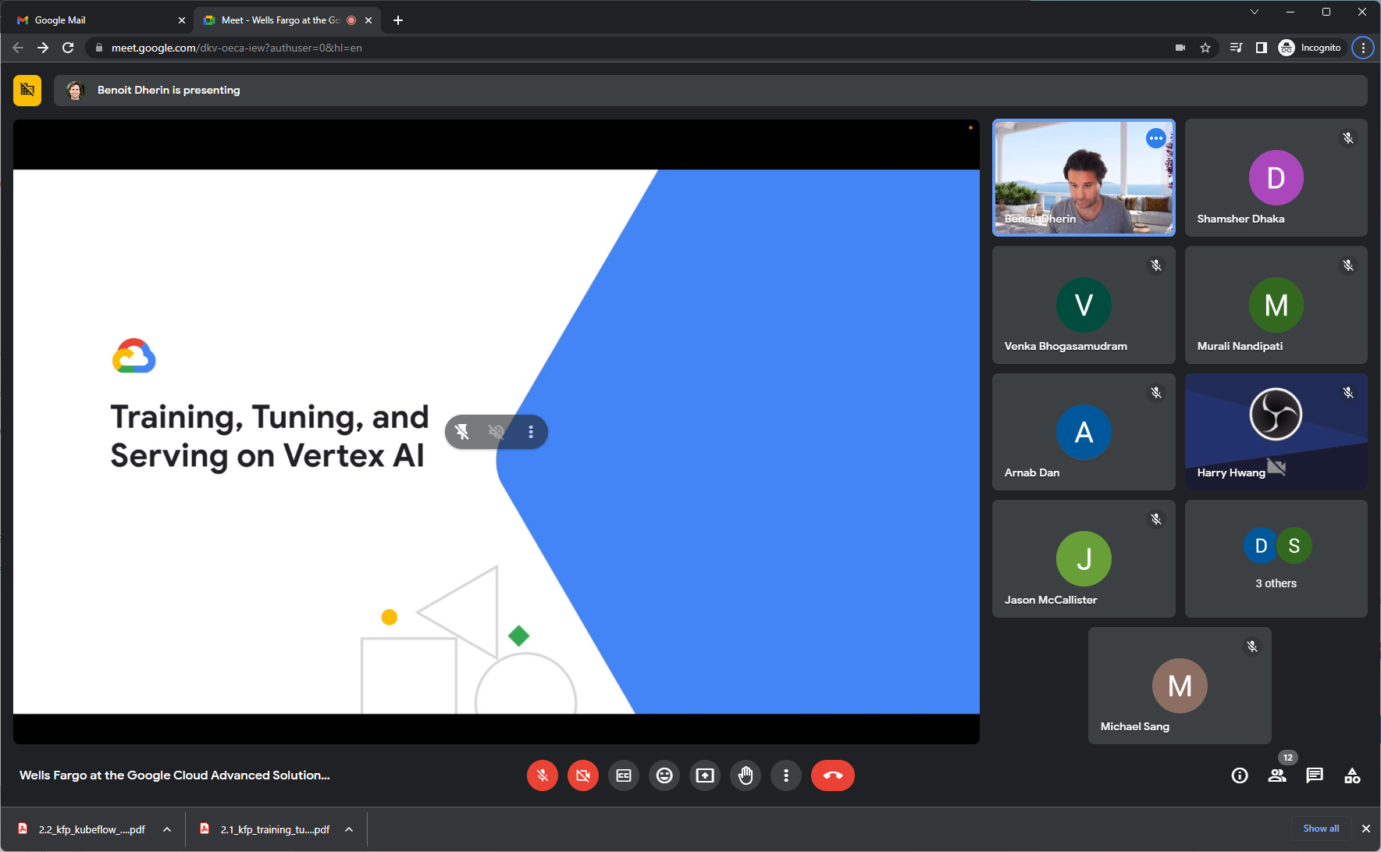

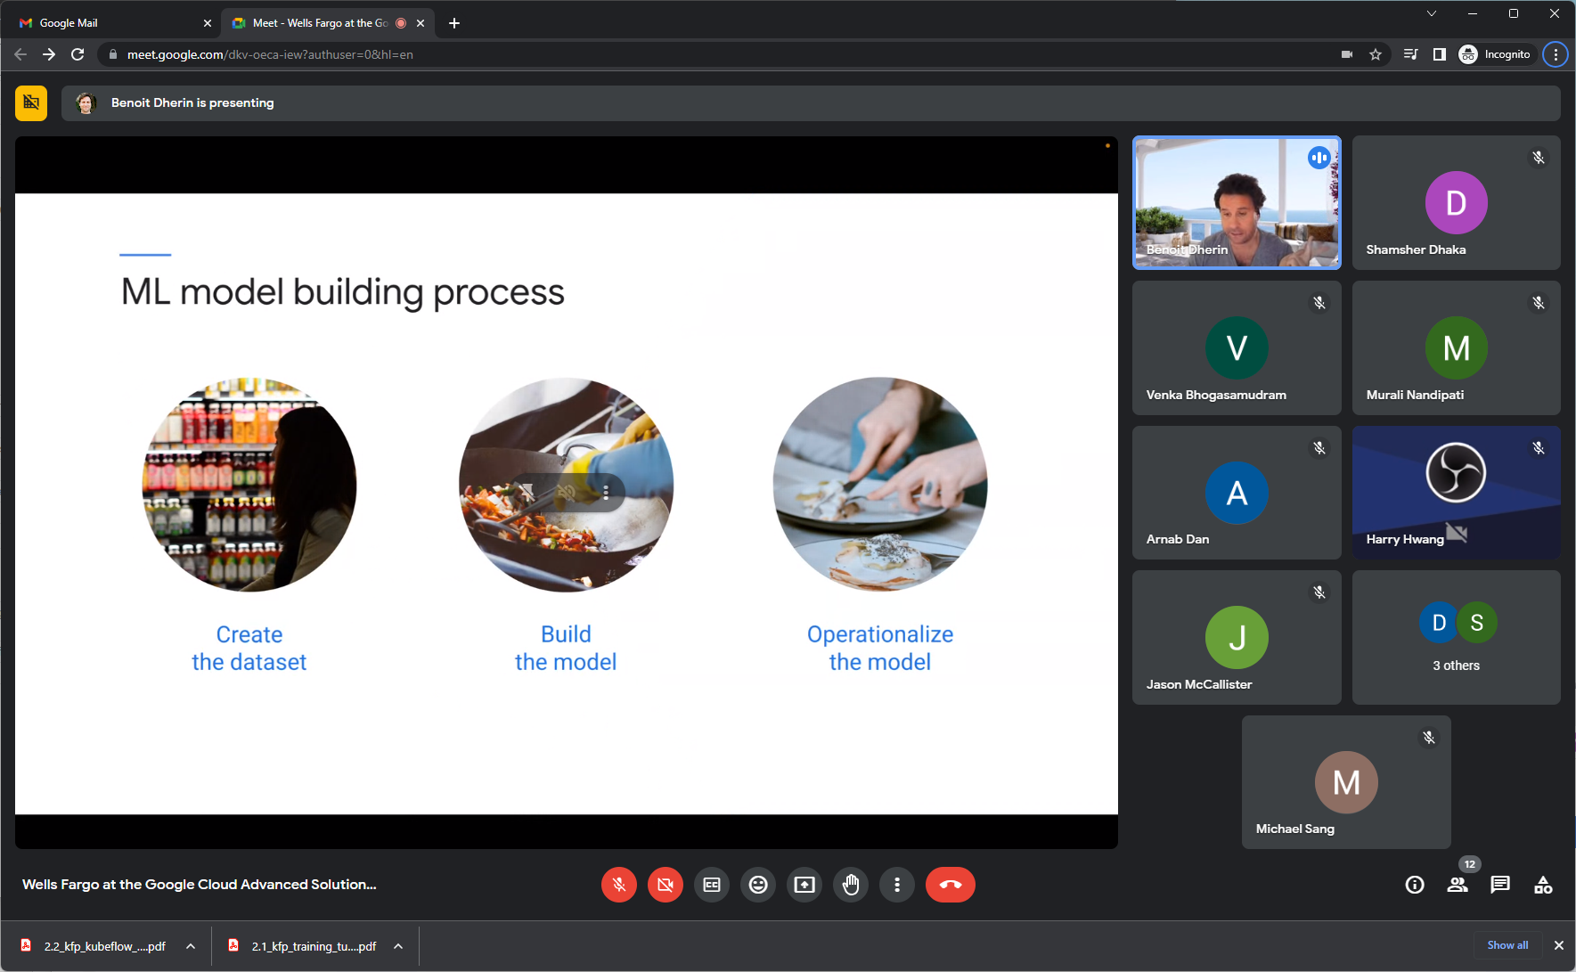

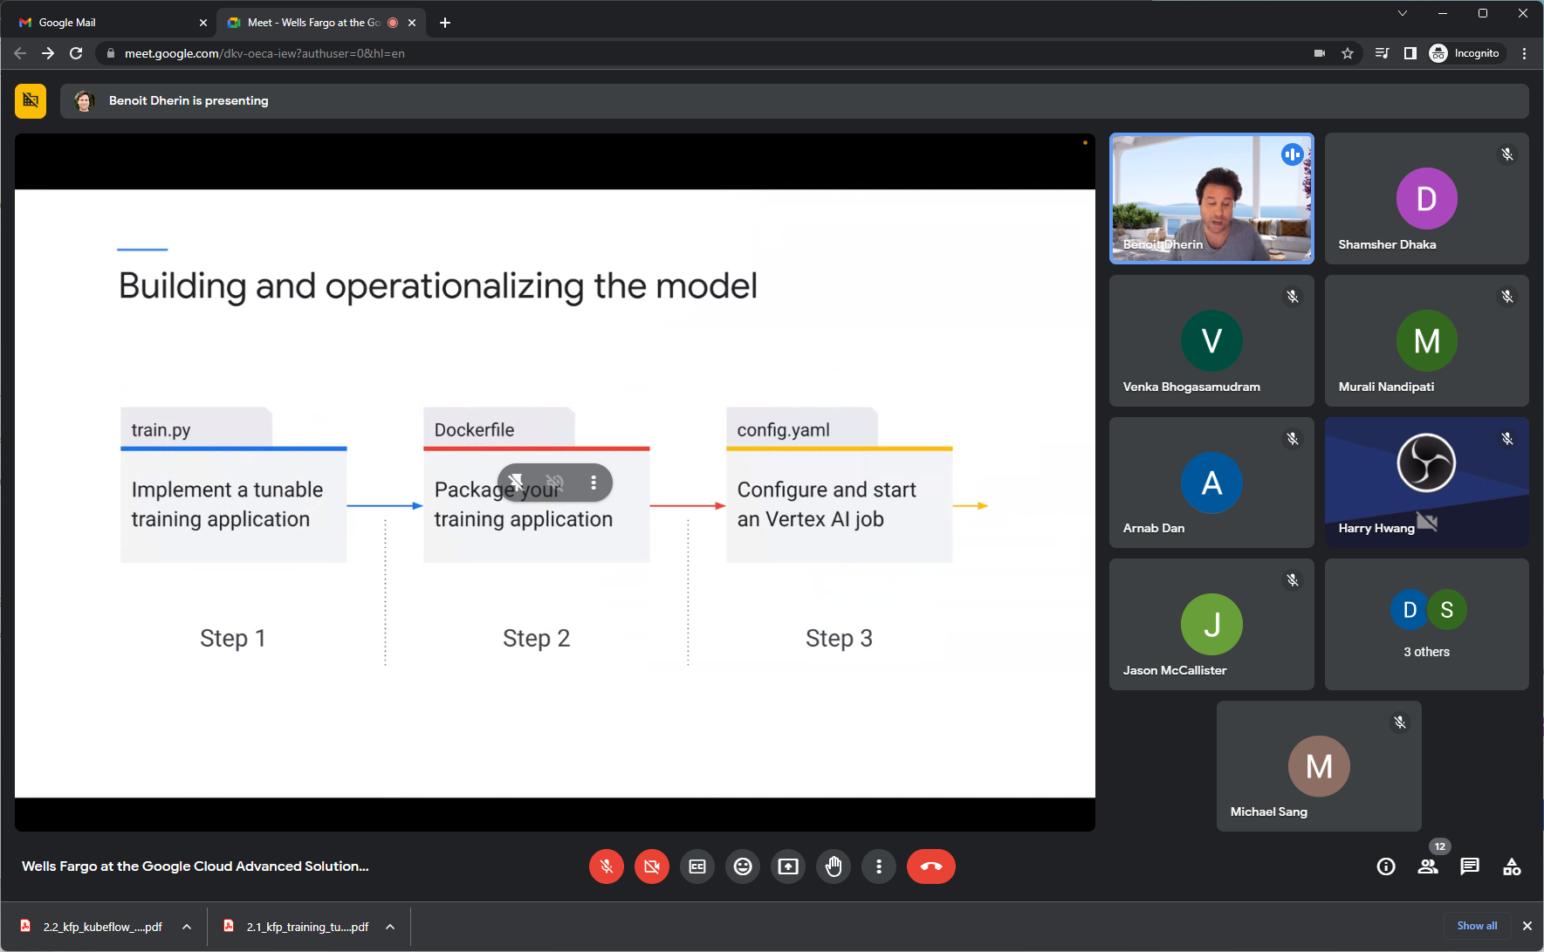

3 steps – artifacts

Not required to write code on vertex…

If want to Integrate code in KFP – NEED a docker file. Container to GCP registry.

Create container and send to container registry. KFP

Containerize training – to make it easy to run training code and to share it as well.. will be on google cloud registry. Also if containerize, can run outside of vertex also. i.e. run it azure or on-prem and not stick to vertex. Need libraries though – can be a mess.

KFP – is one way. Each component is in one container.

Containers – lots of iteration/breakable changes. If want to run anywhere/anytime and protected from libraries… do it a container if run in several years down the road.

MLOPS – one year, two year, can reproduce the same exact model..

Retrain the previous model – to know the same train set.

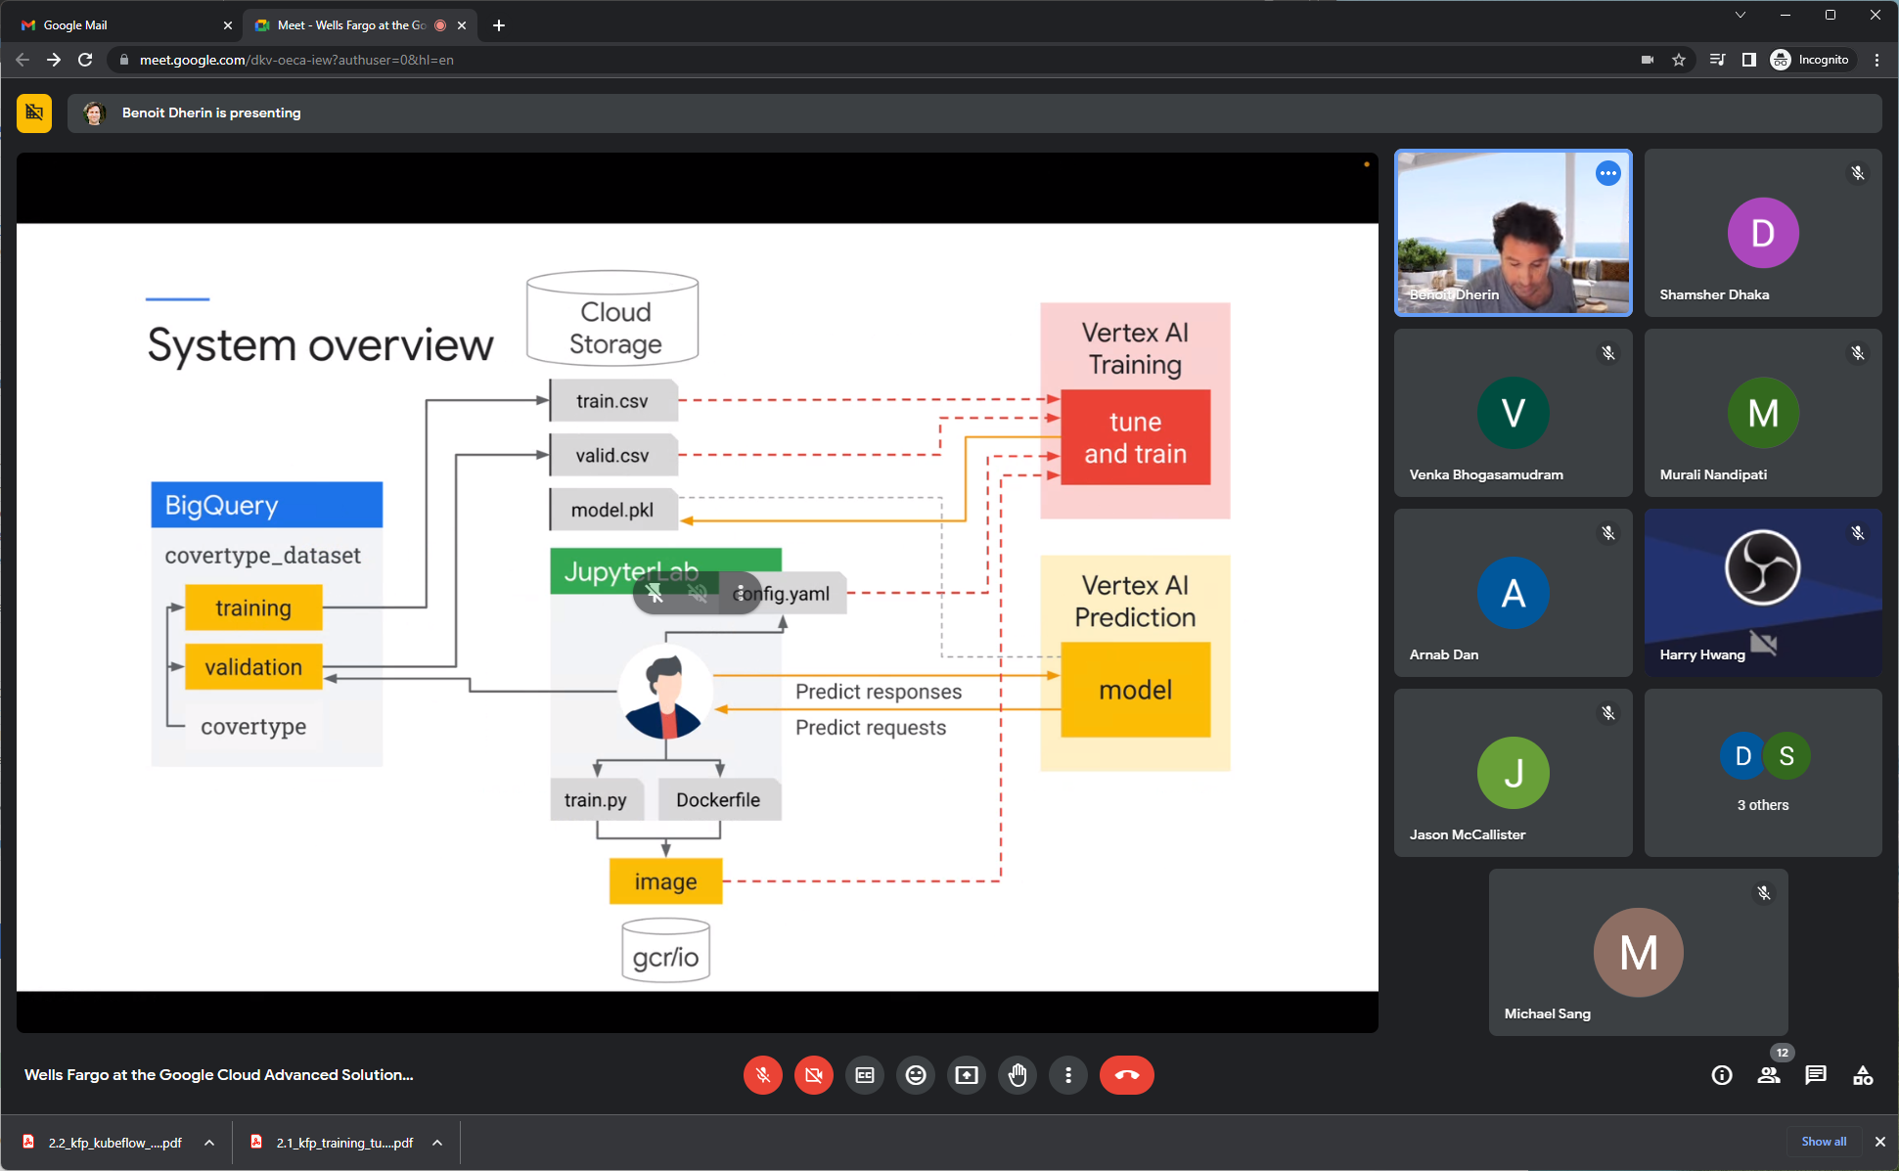

Write docker file with all dependencies to push to GCR (google registry)

Tune/train on vertex AI. Use sci-kit learn. Artifact is a pickle file to serialize on Google cloud storage.

Then do prediction/requests on Vertex AI prediction.

Valid.csv – to evaluate the model.

2 samples – training and one evaluation of model: Never report on train set. Also need evaluation model.

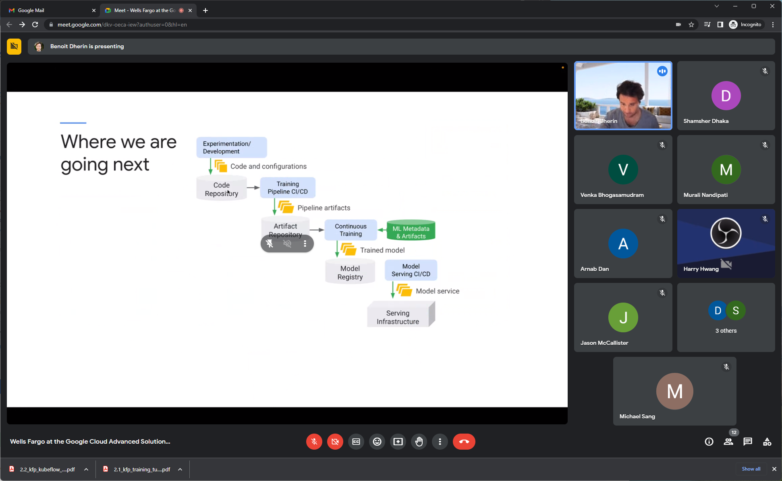

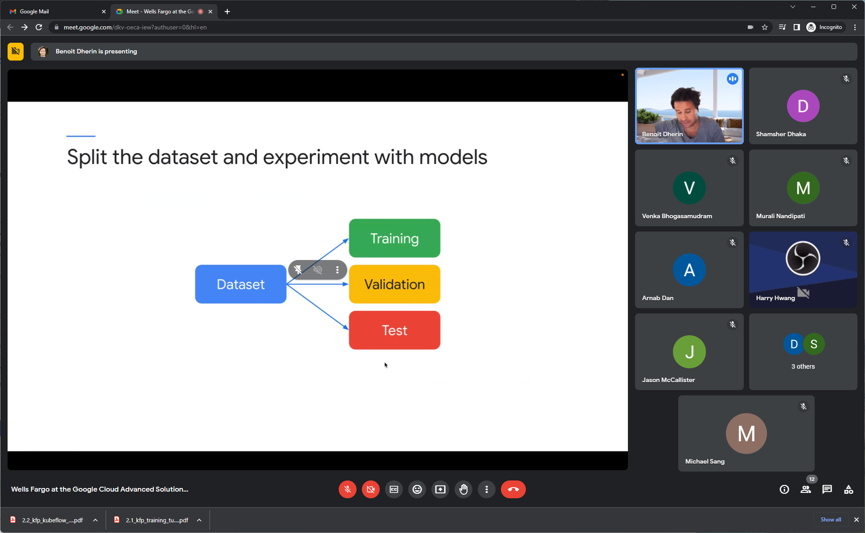

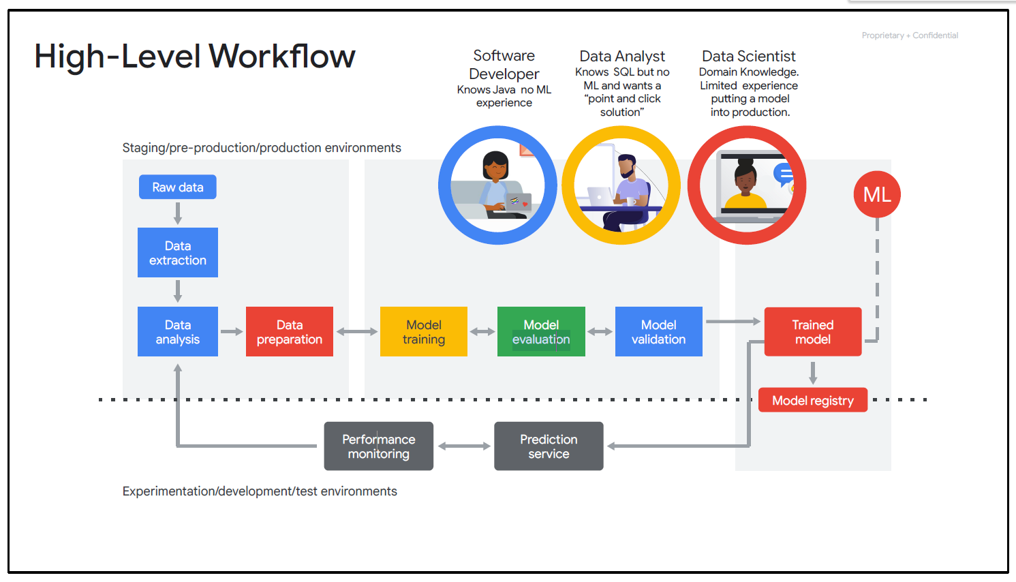

In above, Model Evaluation – is more evaluate performance of model on the TEST SPLIT

But Model Validation – is validation on the previous model when it was trained.. au “Model d’avant”.

* <https://www.cloudskillsboost.google/focuses/1163?parent=catalog>
* <https://cloud.google.com/ai-platform/training/docs/overview>

Provide a way to get training data and evaluation data.

<https://www.tensorflow.org/tfx/tutorials/data_validation/tfdv_basic>

It's also important to look for anomalies in your data, and to compare your training, evaluation, and serving datasets to make sure that they're consistent.

<https://machinelearningmastery.com/difference-test-validation-datasets/>

Generally, the term “validation set” is used interchangeably with the term “test set” and refers to a sample of the dataset held back from training the model.

* <https://cloud.google.com/vertex-ai/docs/evaluation/introduction>

*The model evaluation provided by Vertex AI can fit in the typical machine learning workflow in several ways:*

1. *After you train your model, review model evaluation metrics before you deploy your model. You can compare evaluation metrics across multiple models to help you decide which model you should deploy.*
2. *After your model is deployed to production, periodically evaluate your model with new incoming data. If the evaluation metrics show that your model performance is degrading, consider re-training your model. This process is called*continuous evaluation*.*

Benoit Dherin

1:33 PM

For the question concerning the number of container that can run into a pod, there is no limit. Although there are some Kubernetes general limits:

No more than 110 pods per node. No more than 5000 nodes. No more than 150000 total pods. No more than 300000 total containers.

In our exercise, there were 2 NODES – and gcp UI mentions no more than 110 pods per node.

: Here is an example of a small webapp that queries a deployed endpoint: [https://github.com/GoogleCloudPlatform/asl-ml-immersion/blob/master/notebooks/end-to-end-structured/solutions/app/app. py#L24-L34](https://github.com/GoogleCloudPlatform/asl-ml-immersion/blob/master/notebooks/end-to-end-structured/solutions/app/app.%20py#L24-L34)

----------------------

Validation – which hyperparameters are working the best.

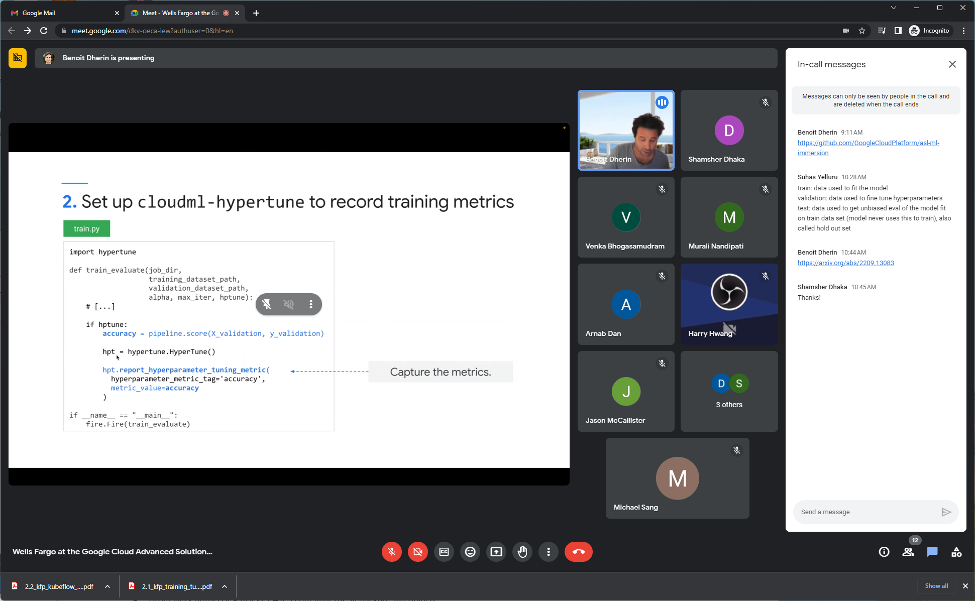

Training and evaluation done.

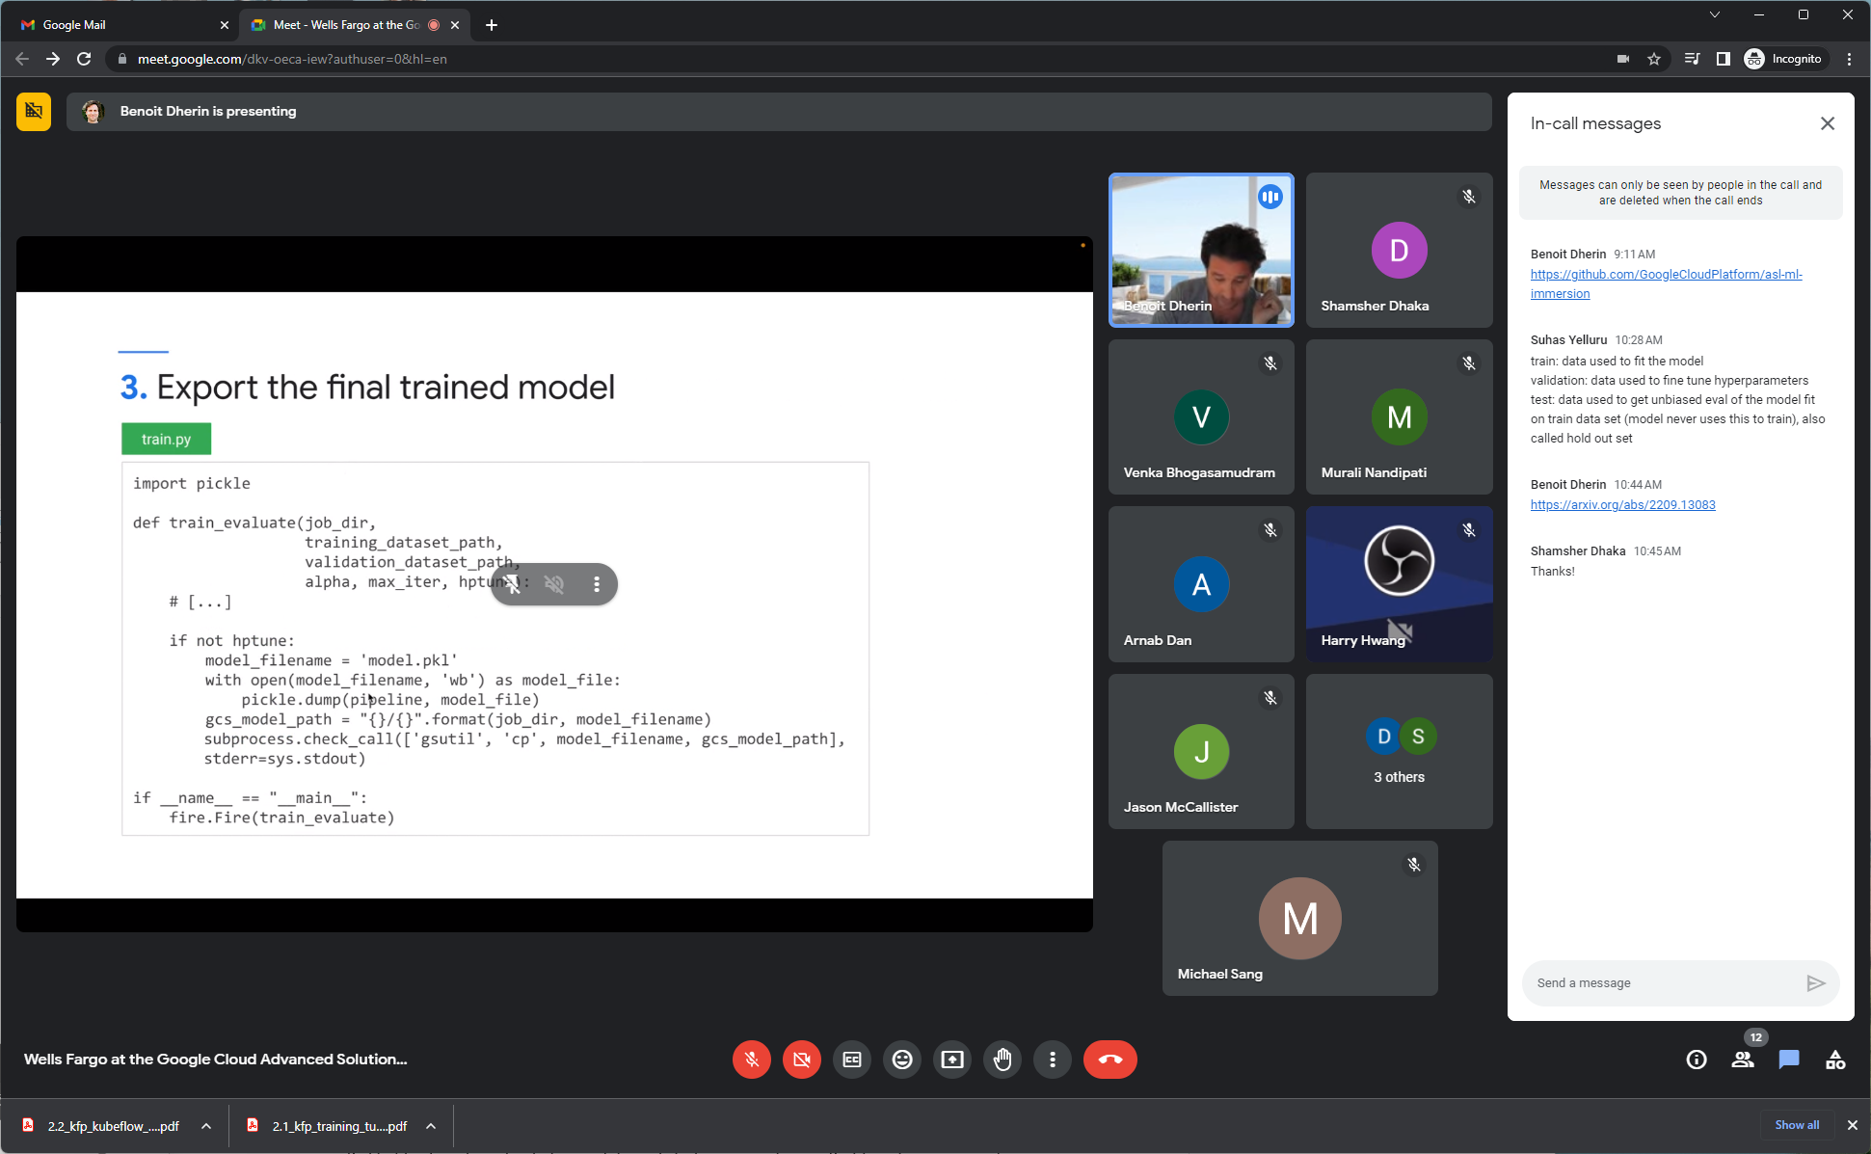

Serialize with a pickle of model with trained weights and dump that to a Google cloud storage path.

<https://arxiv.org/abs/2209.13083>

Suhas Yelluru

10:28 AM

train: data used to fit the model validation: data used to fine tune hyperparameters test: data used to get unbiased eval of the model fit on train data set (model never uses this to train), also called hold out set

config.yaml:

tell vertex which metrics to MAXIMIZE

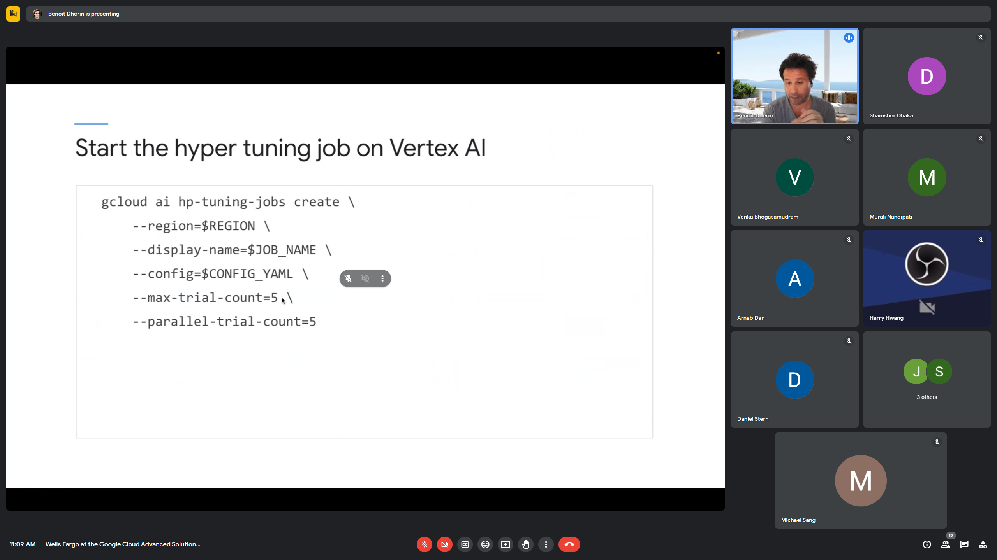

Max-trial-count : total number of computes. Here 5 is very small.

Parallel-trial-count : If 1 try each possible configuration one time. 2nd trial have info of 1st trial… 5th trial will have the first 4 trials to compute param. Tuning job will be longer.

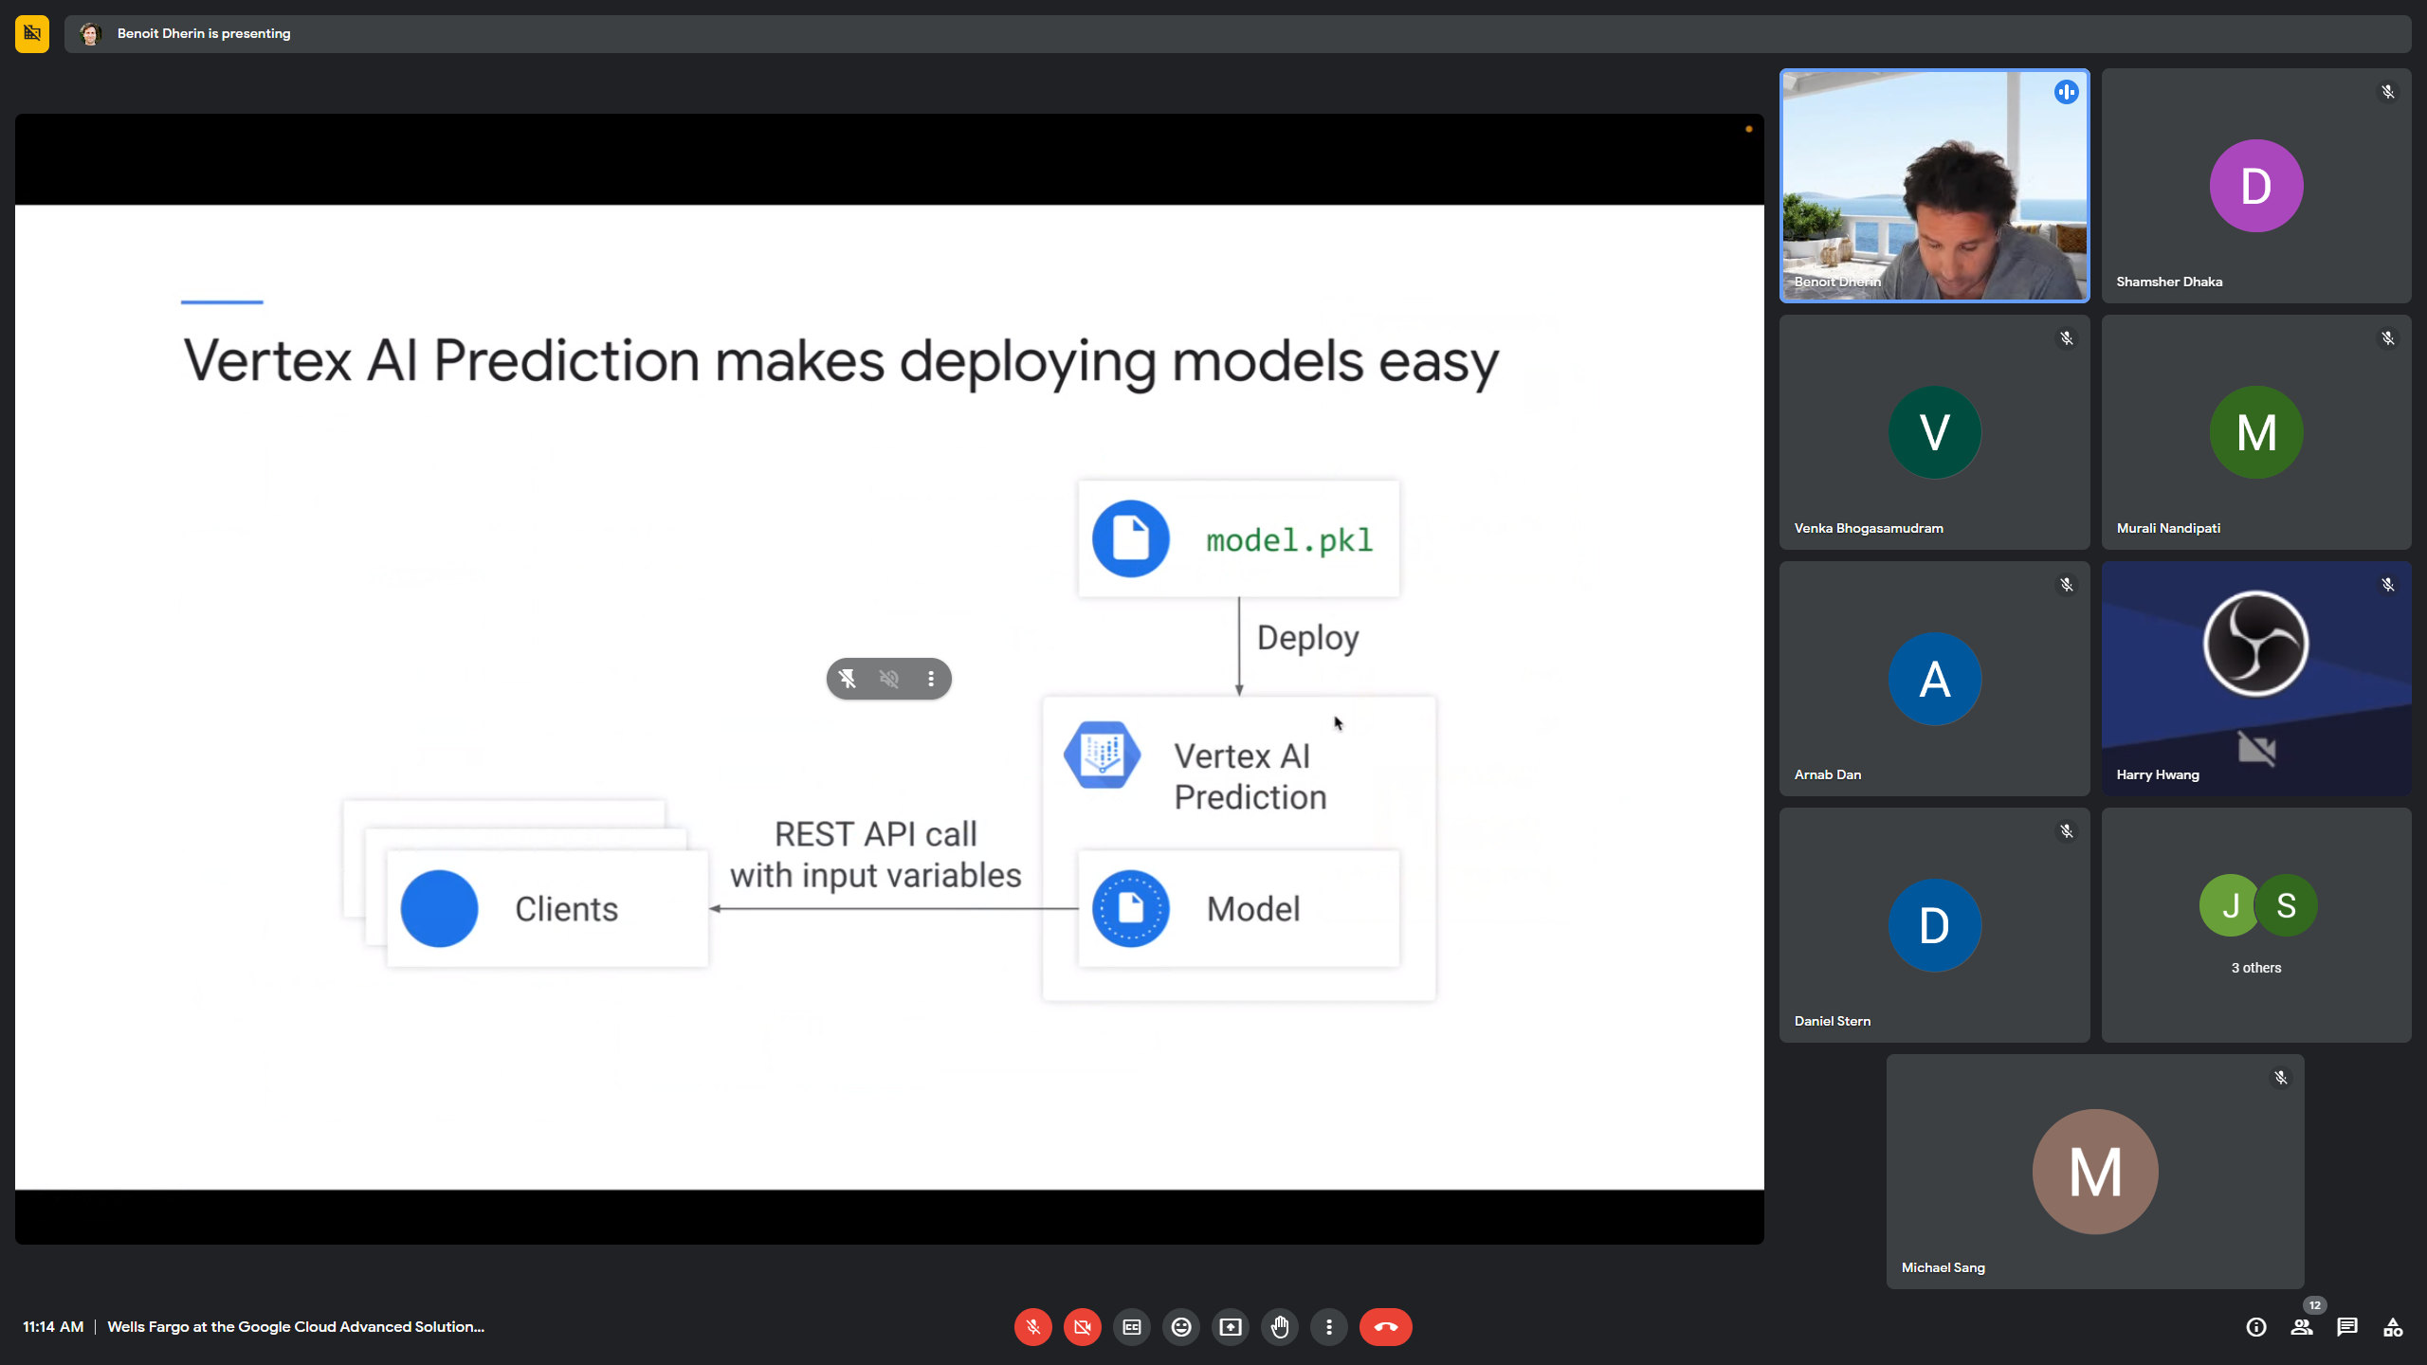

Deploy pkl to vertex ai prediction.

Cluster – not more than 1000

For the question concerning the number of container that can run into a pod, there is no limit. Although there are some Kubernetes general limits:

No more than 110 pods per node. No more than 5000 nodes. No more than 150000 total pods. No more than 300000 total containers.

REVIEW kfp-walthrough-vertex workbook:

Create training set – upload dataset into BQ

Create training table with MOD Trick.

Get 1/10 of data?

Level 1-containerized training.

Venka Bhogasamudram

2:29 PM

gs://asl-public/data/arthropod/ gs://asl-public/data/car_damage_lab_images/ gs://asl-public/data/churn/ gs://asl-public/data/coco-small/ gs://asl-public/data/covertype/ gs://asl-public/data/flights/ gs://asl-public/data/flowers/ gs://asl-public/data/image_caption/ gs://asl-public/data/movie-descriptions/ gs://asl-public/data/salads/ gs://asl-public/data/tensorflow_datasets/ gs://asl-public/data/titles/

!gsutil ls gs://asl-public/data

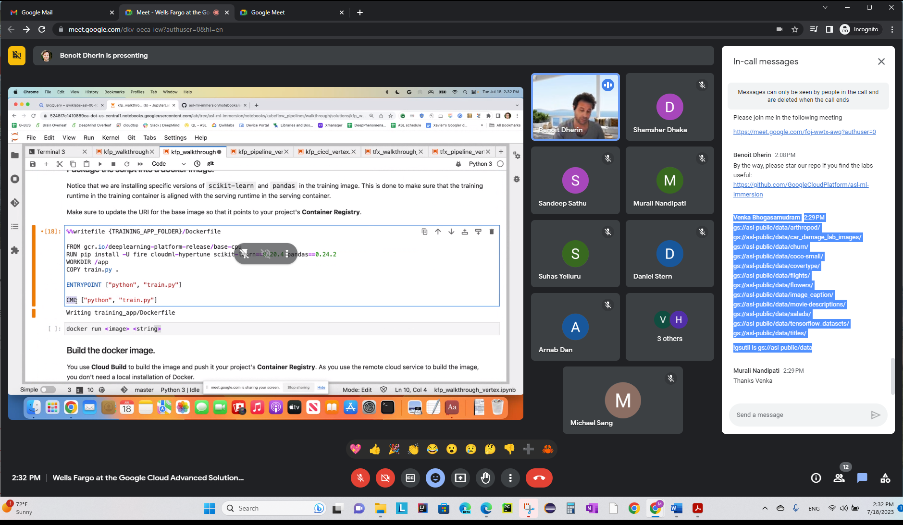

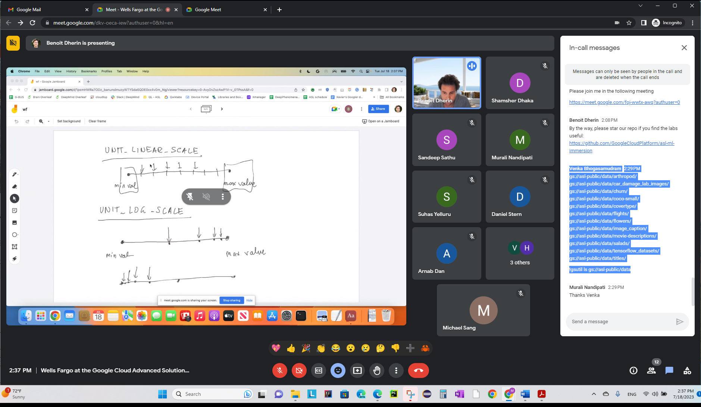

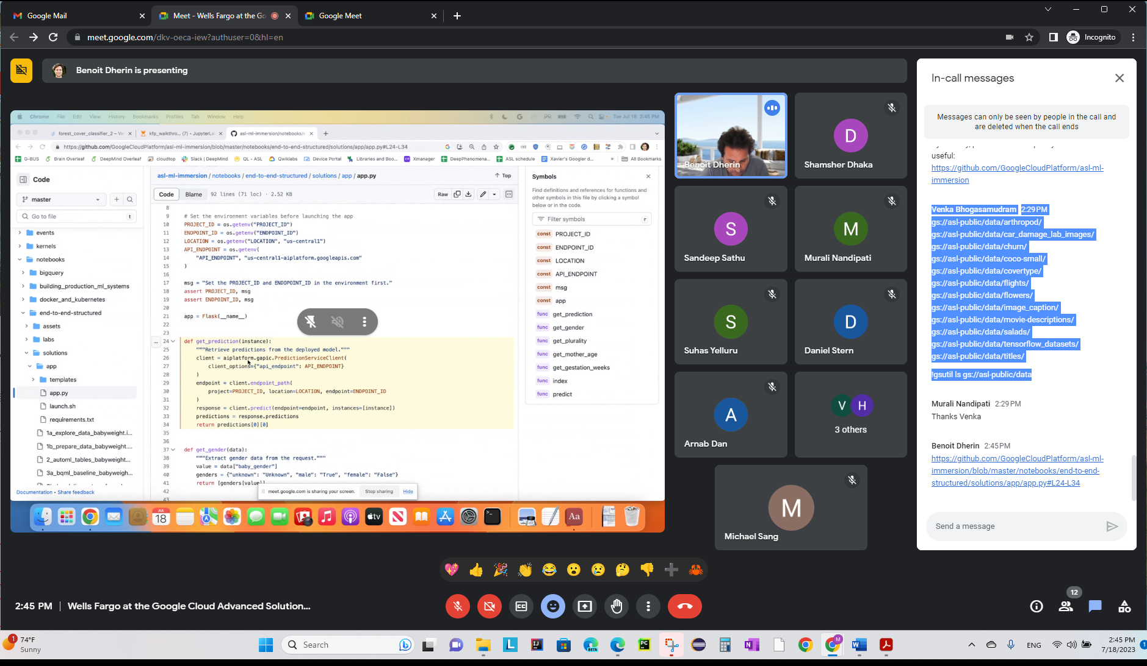

Above how to use endpoint OUTSIDE of the notebook.

**NEXT STEP: HOW TO AUTOMATE WORKFLOW USING ML PIPELINES (THIS IS LEVEL #2)**

MODEL CODE

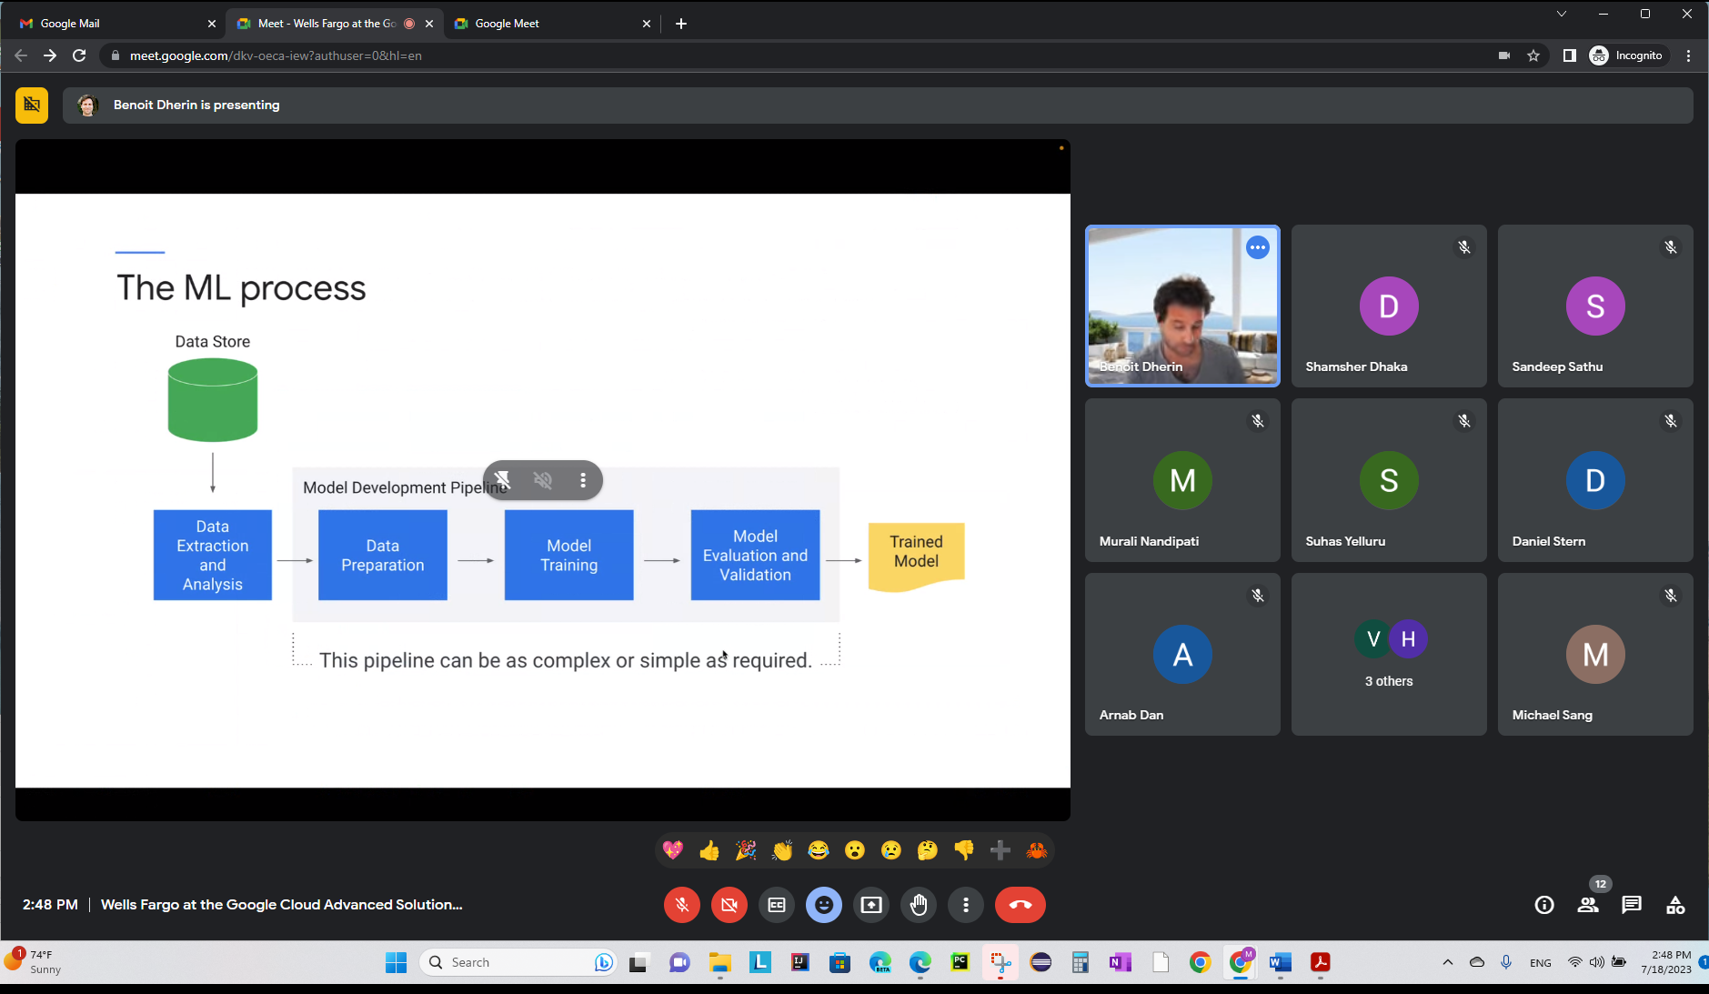

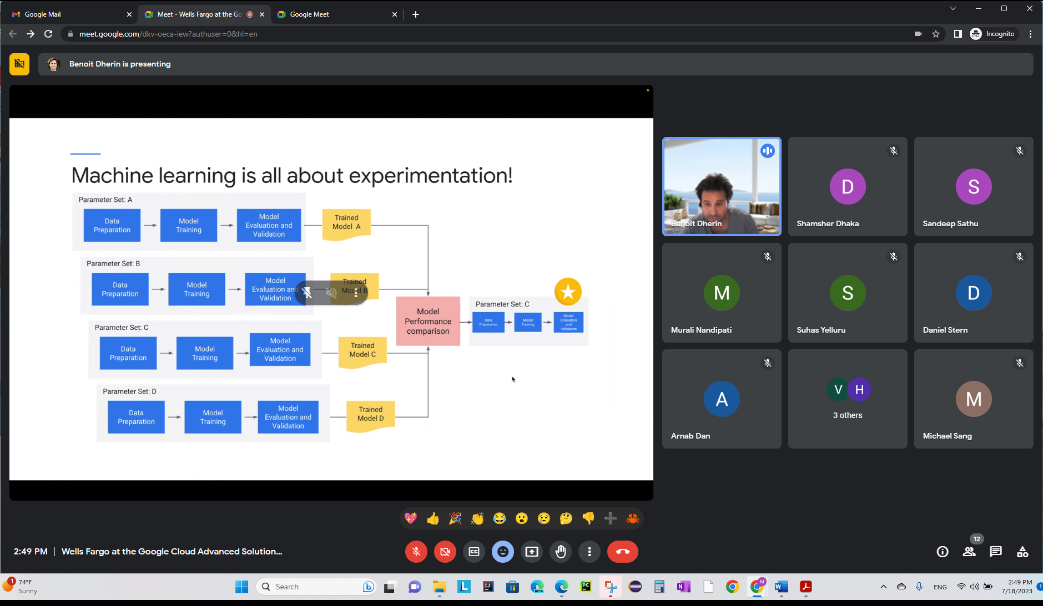

KFP – is a standardized platform for ML pipeline…

KFP Pipeline.

Upload artifact to vertex pipeline and run it.

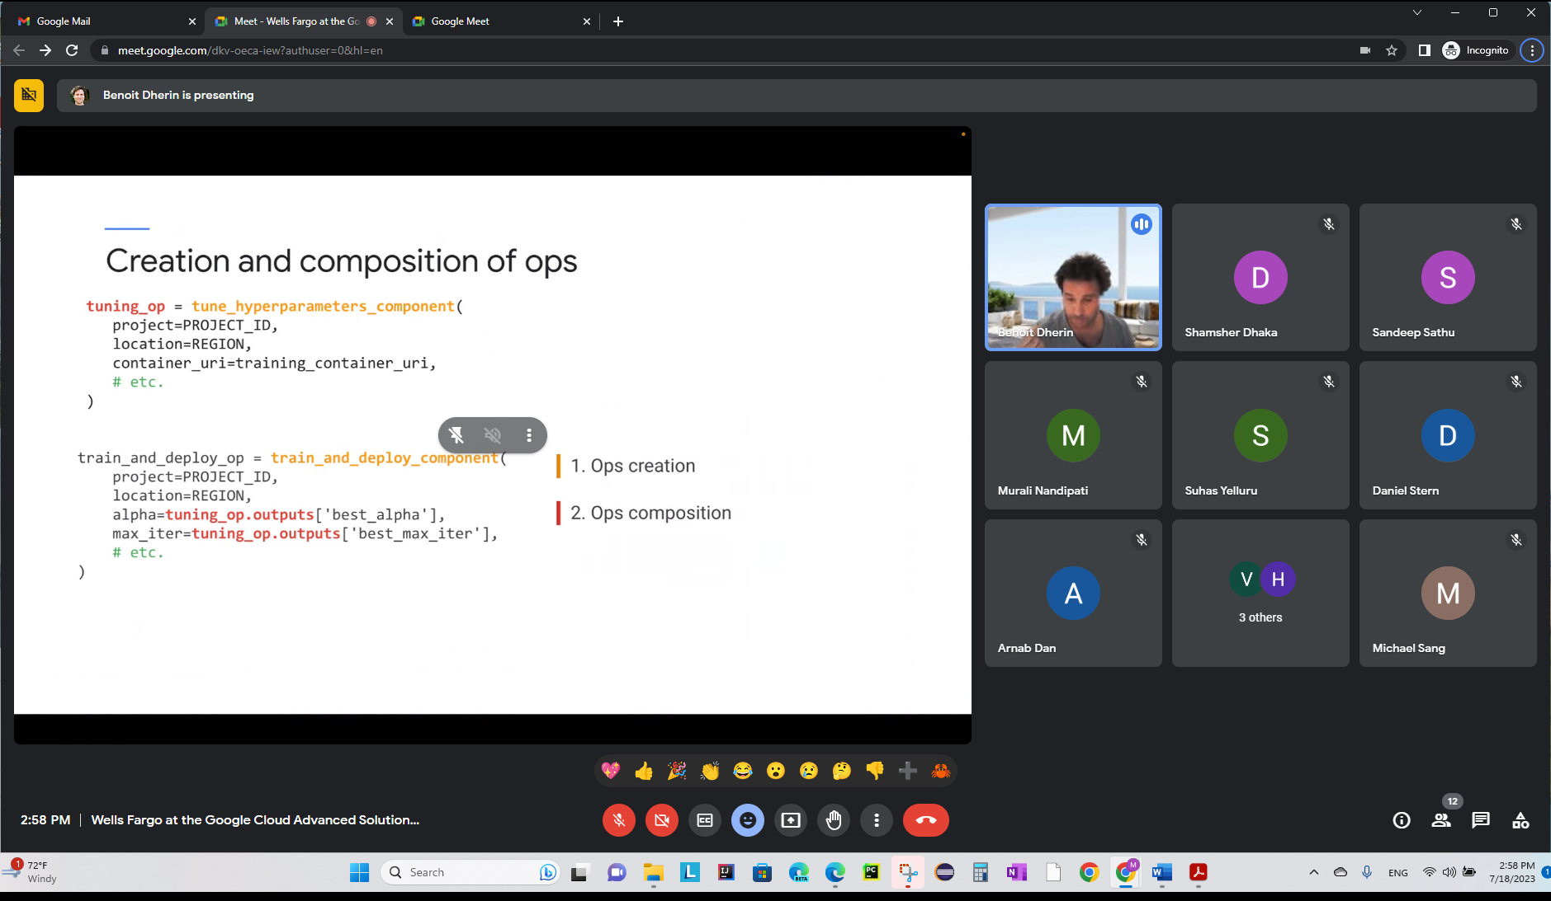

If accuracy below threshold, don’t deploy it. Check using the condition.

dsl is a module in KFP library.

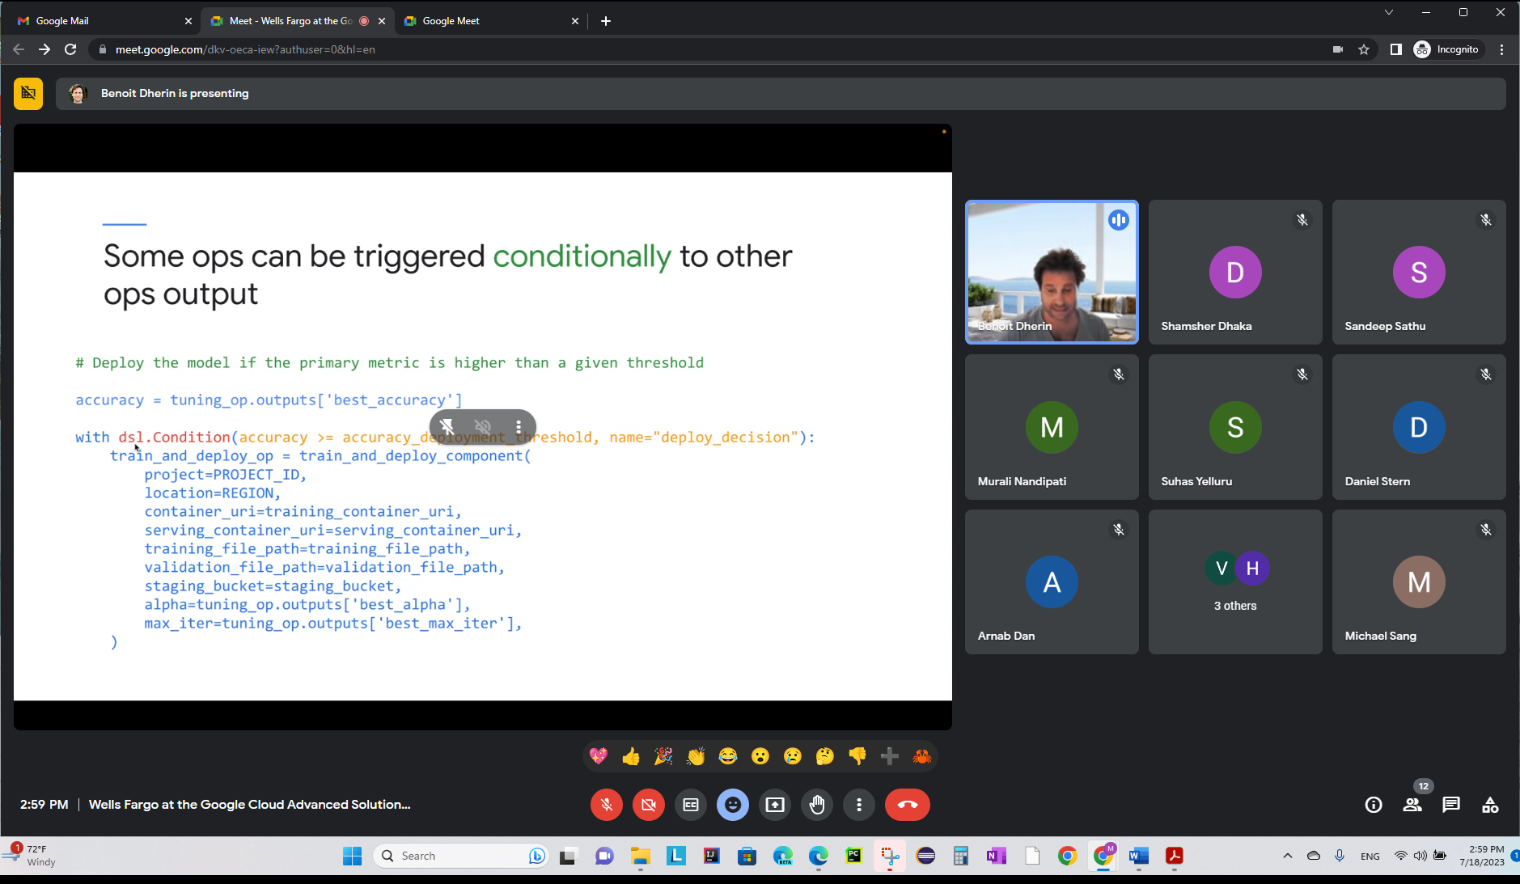

KFP – has lightweight python components. Wrap it into KFP component using a special decorator.

1. All containers need to be uploaded to registry.
2. Compile KFP pipeline

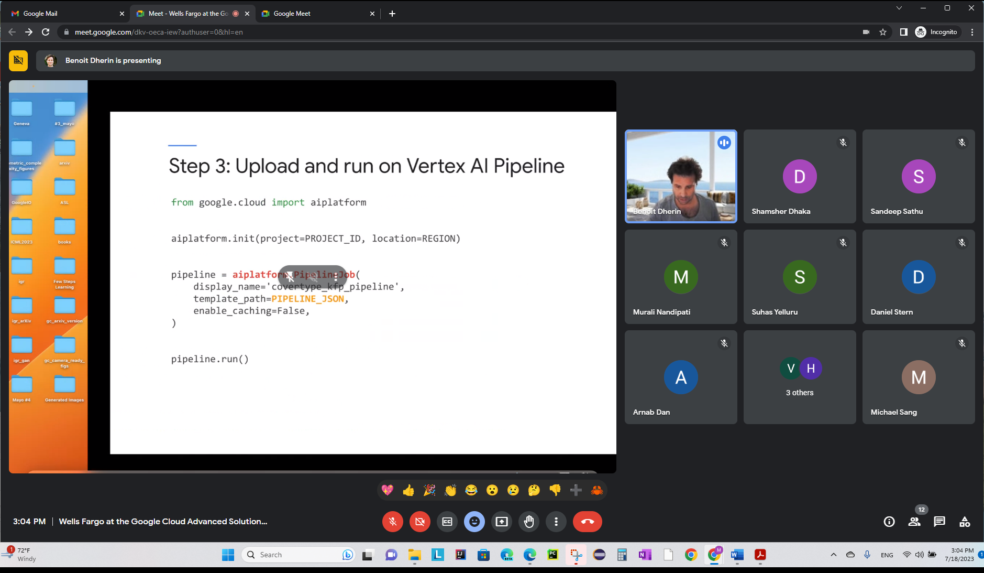

Need PIPELINE_JSON artifact..

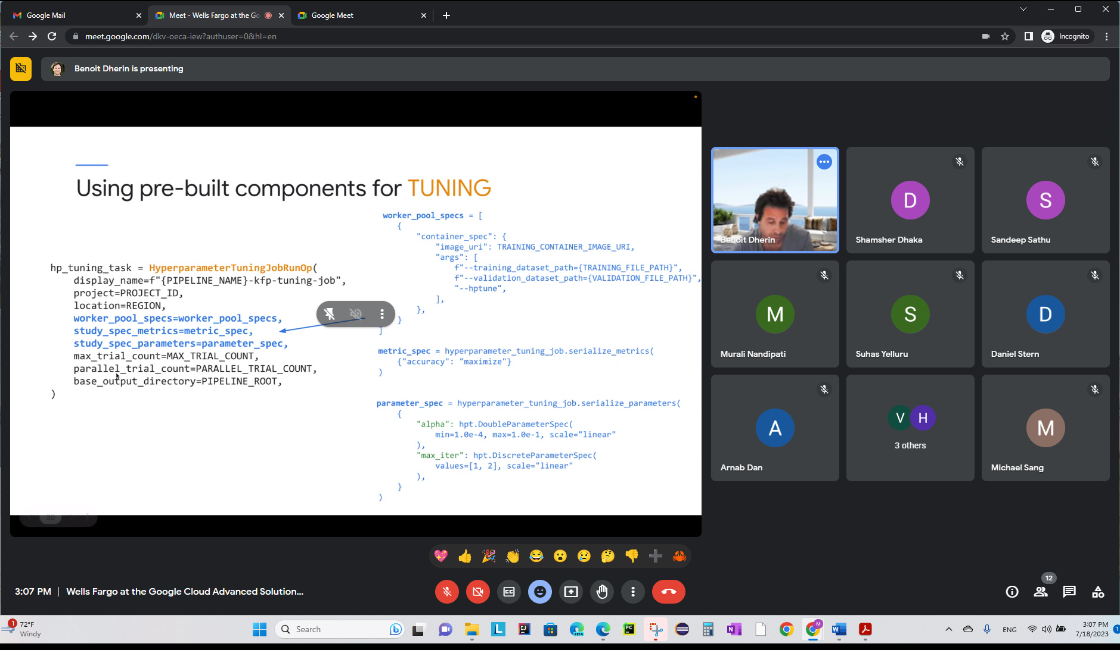

DiscreteParameterSpec – is the type of the HPT Parameter.

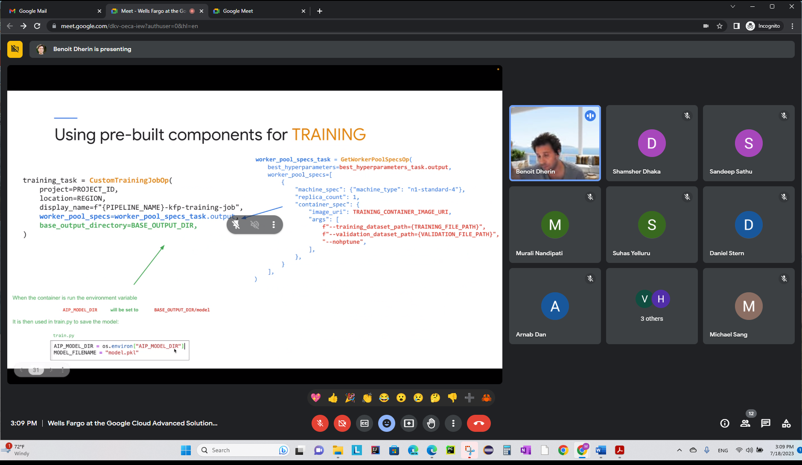

pkl file saved as an environment variable.

**Build component with Lightweight Python Components**

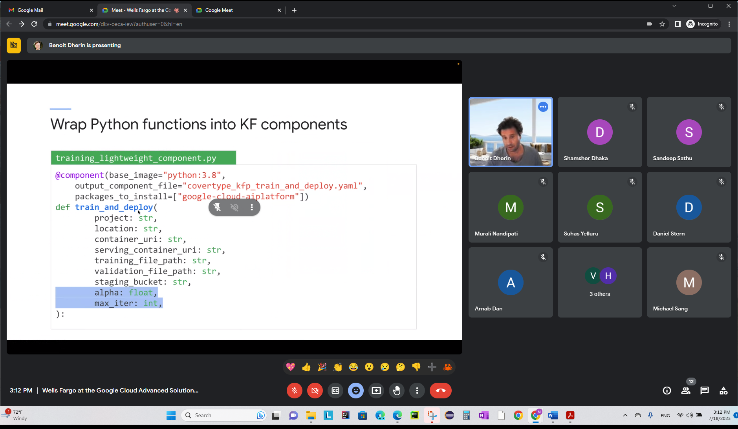

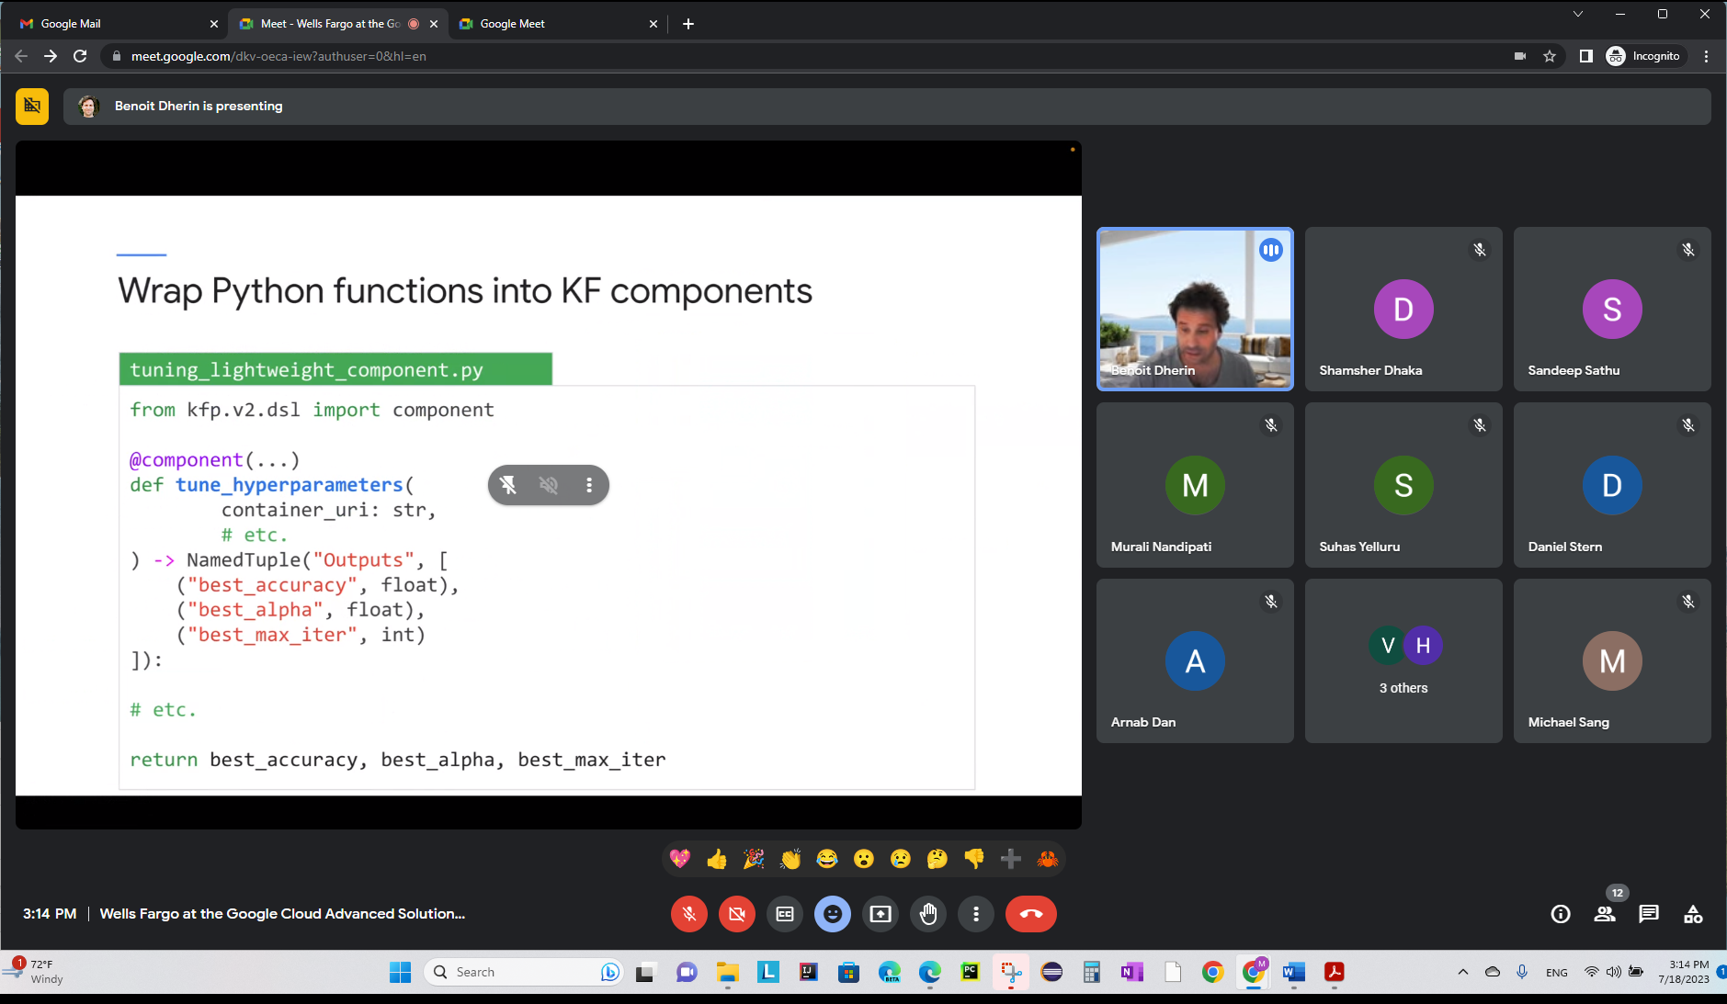

Output directory and tell KFP that it’s a NamedTuple etc. above. Above is to do your own component with PYTHON! To implement your own Lightweight python component in KFP!

Level 0 – work in your own workbook

Level 1 - containerize

EXCEPT – AutoML pipeline.. it does all the training, tuning of your model. Just focus on AutoML pipeline!

**Notebook: kfp_pipeline_vertex_perbuilt.ipynb – Viewing Pipeline Job:**

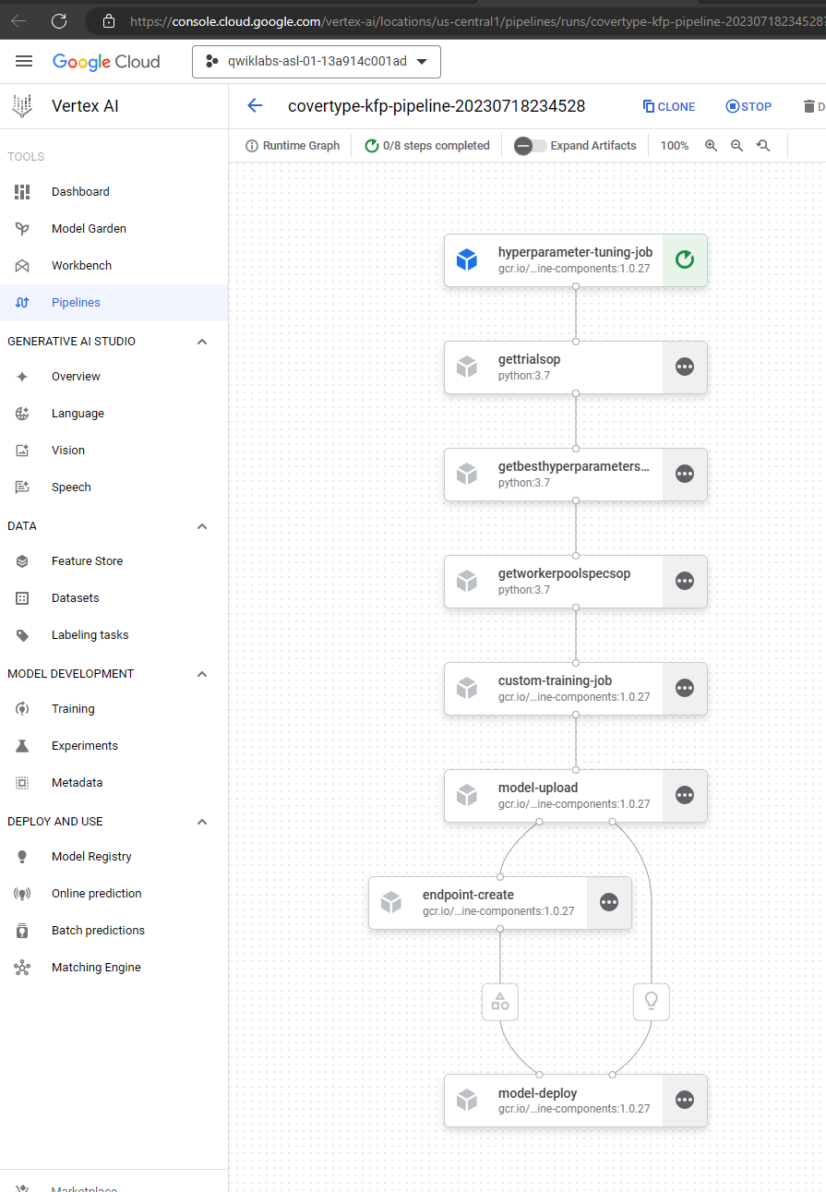

(base) jupyter@mlops:~/asl-ml-immersion/notebooks/docker_and_kubernetes/labs$ gsutil ls gs://asl-public/data

gs://asl-public/data/arthropod/

gs://asl-public/data/car_damage_lab_images/

gs://asl-public/data/churn/

gs://asl-public/data/coco-small/

gs://asl-public/data/covertype/

gs://asl-public/data/flights/

gs://asl-public/data/flowers/

gs://asl-public/data/image_caption/

gs://asl-public/data/movie-descriptions/

gs://asl-public/data/salads/

gs://asl-public/data/tensorflow_datasets/

gs://asl-public/data/titles/

(base) jupyter@mlops:~/asl-ml-immersion/notebooks/docker_and_kubernetes/labs$

7/19/2023

Vertex pipeline – is just kubeflow pipeline on GCP!

Create a single artifact container image to run anywhere.

Compile single artifact

Can debug a pipeline – use “Pipeline run proto”

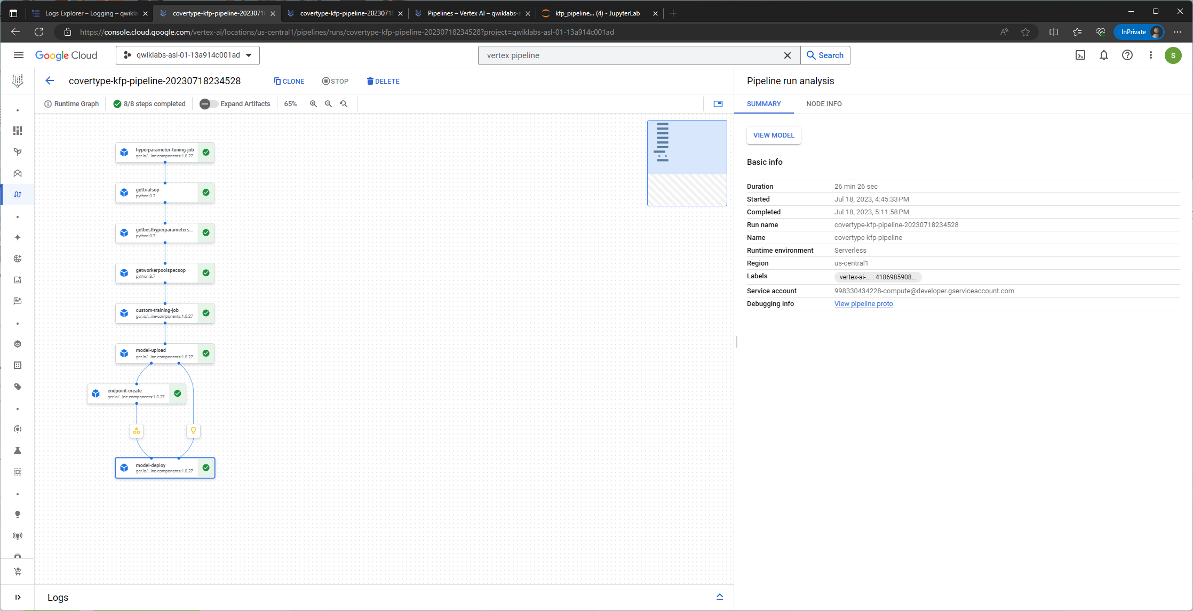

When an artifact created – endpoint…

Pipeline meta data – written into a storage

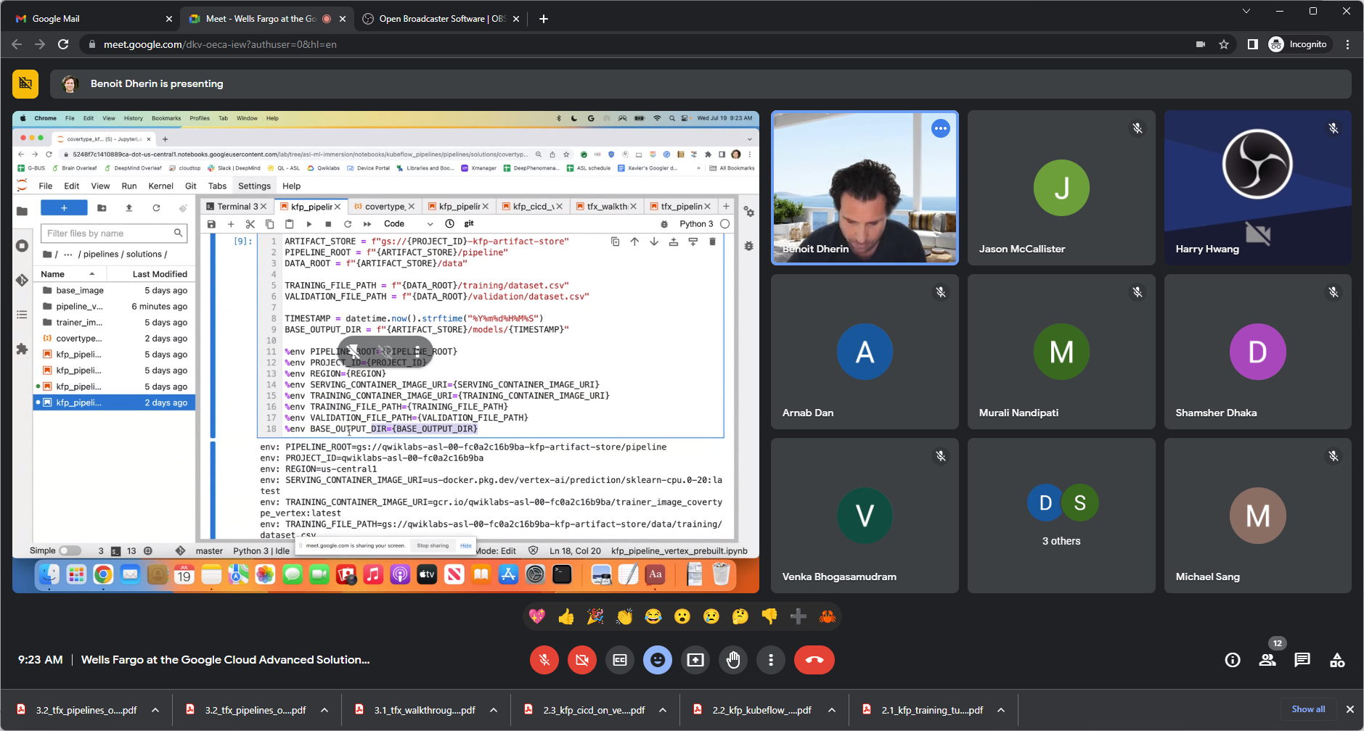

Set the environment variables before compiling the pipeline.

Job/Operation/task/component/ different wordings – all these meaning single docker container that is running!

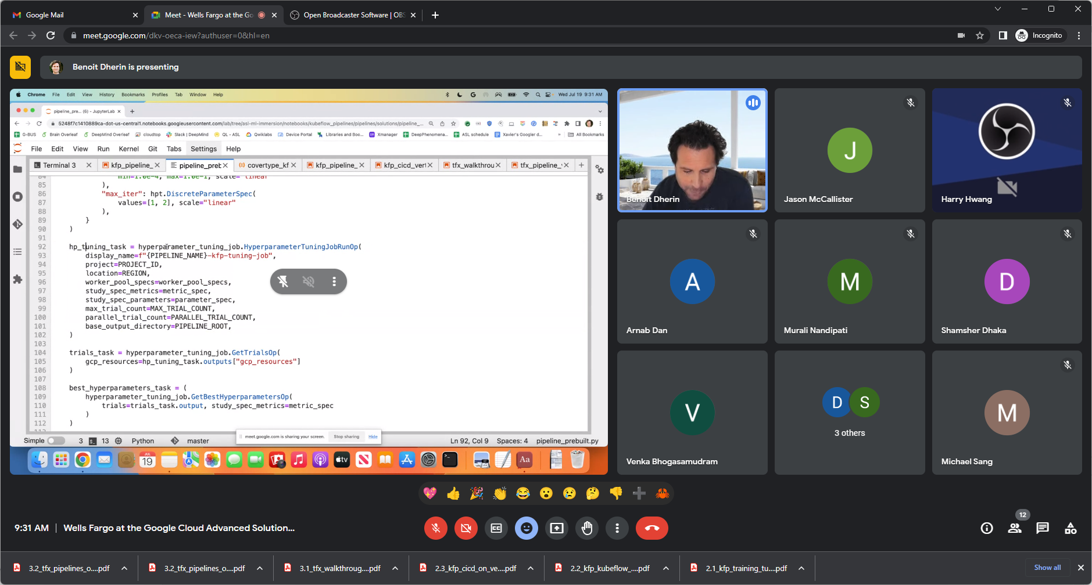

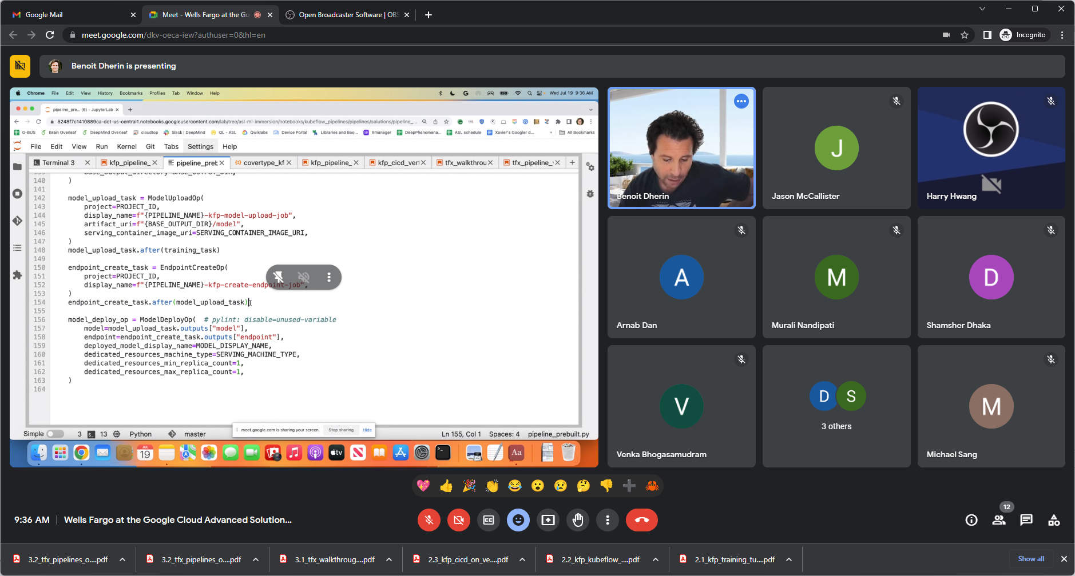

Above say .after to run after model created.

Each component has an output dictionary.

Can have custom input.

Can mix/match custom component with prebuilt component.. so for custom if a task is done, can have a flag saying it’s done.

Using CI/CD pipeline to build/run/push container.

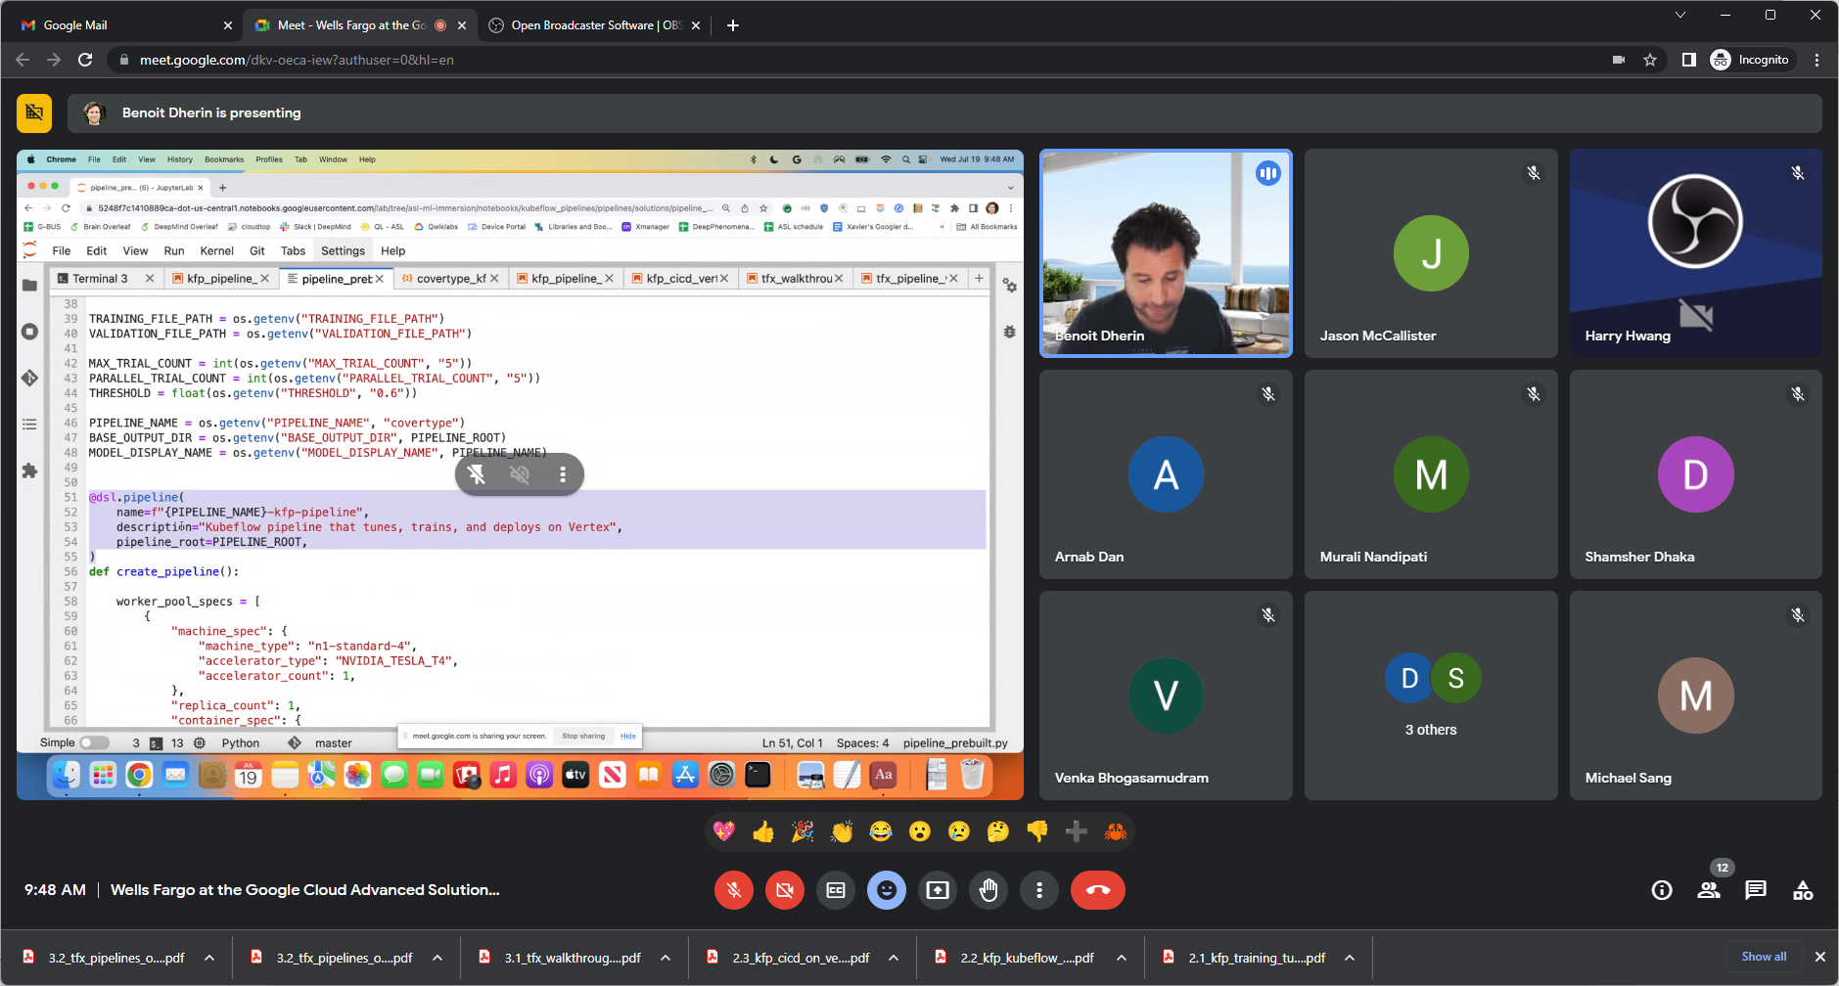

Use dsl decorator to tell Kubeflow pipeline

Then specifiy which component to run after which..

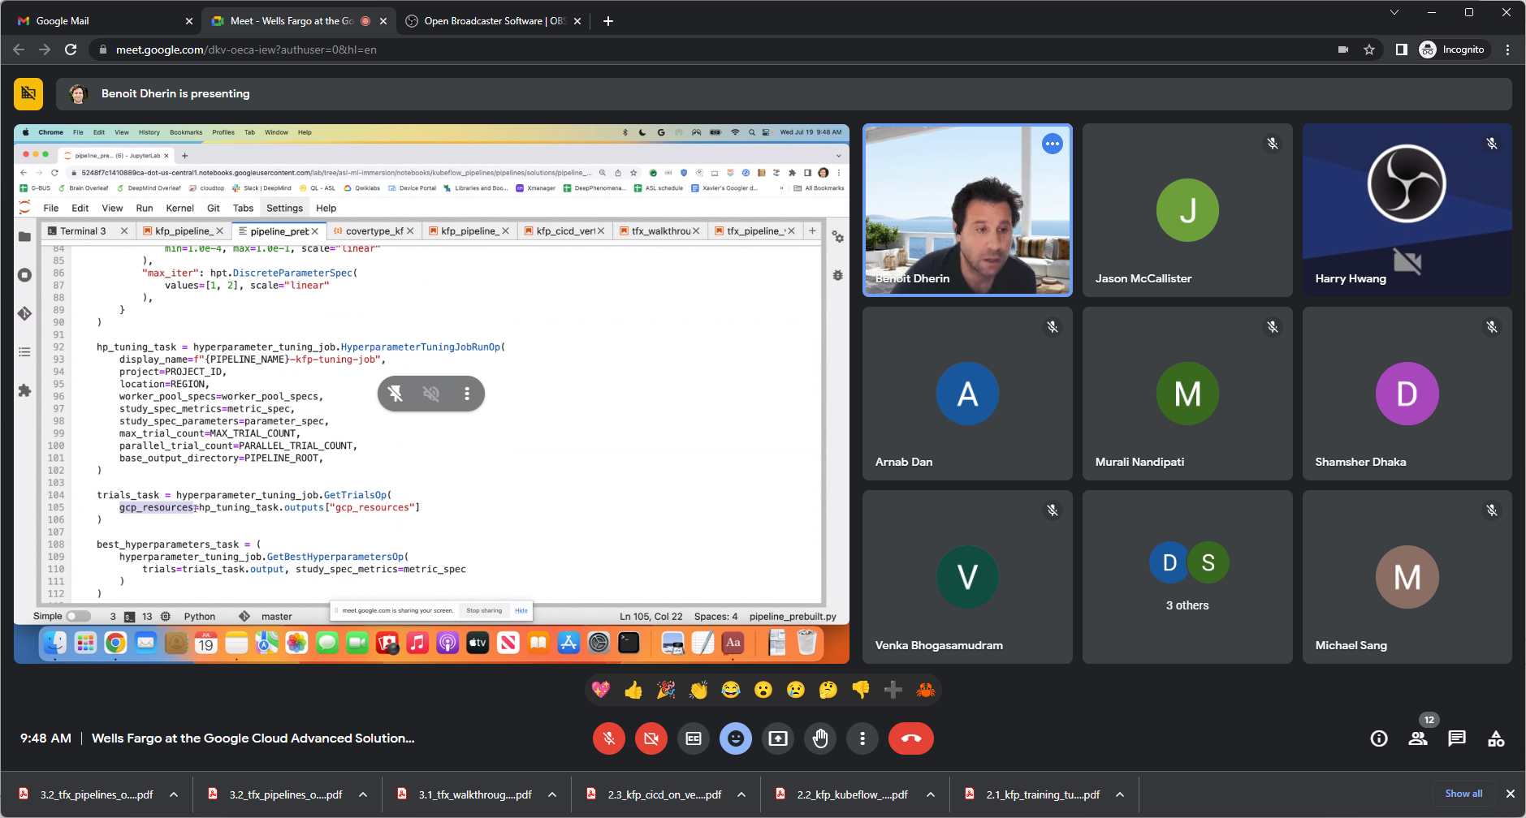

Above retrieve output of previous component hp_tuning_Task.

If a task not rely on output of any other components, then do endpoint_create_task.after(model_upload_task)

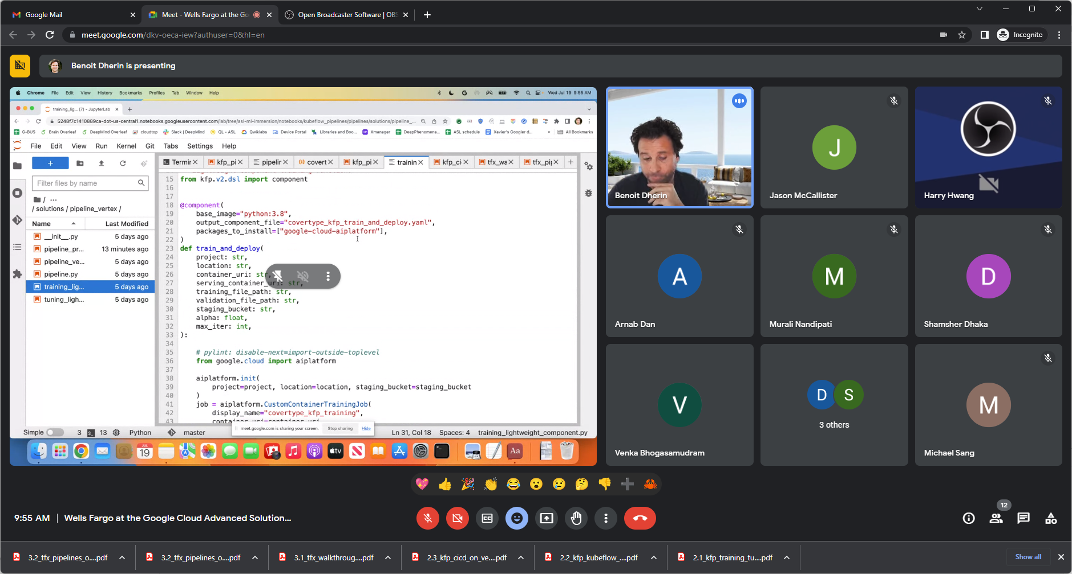

Specify a component here… No need to write the container.

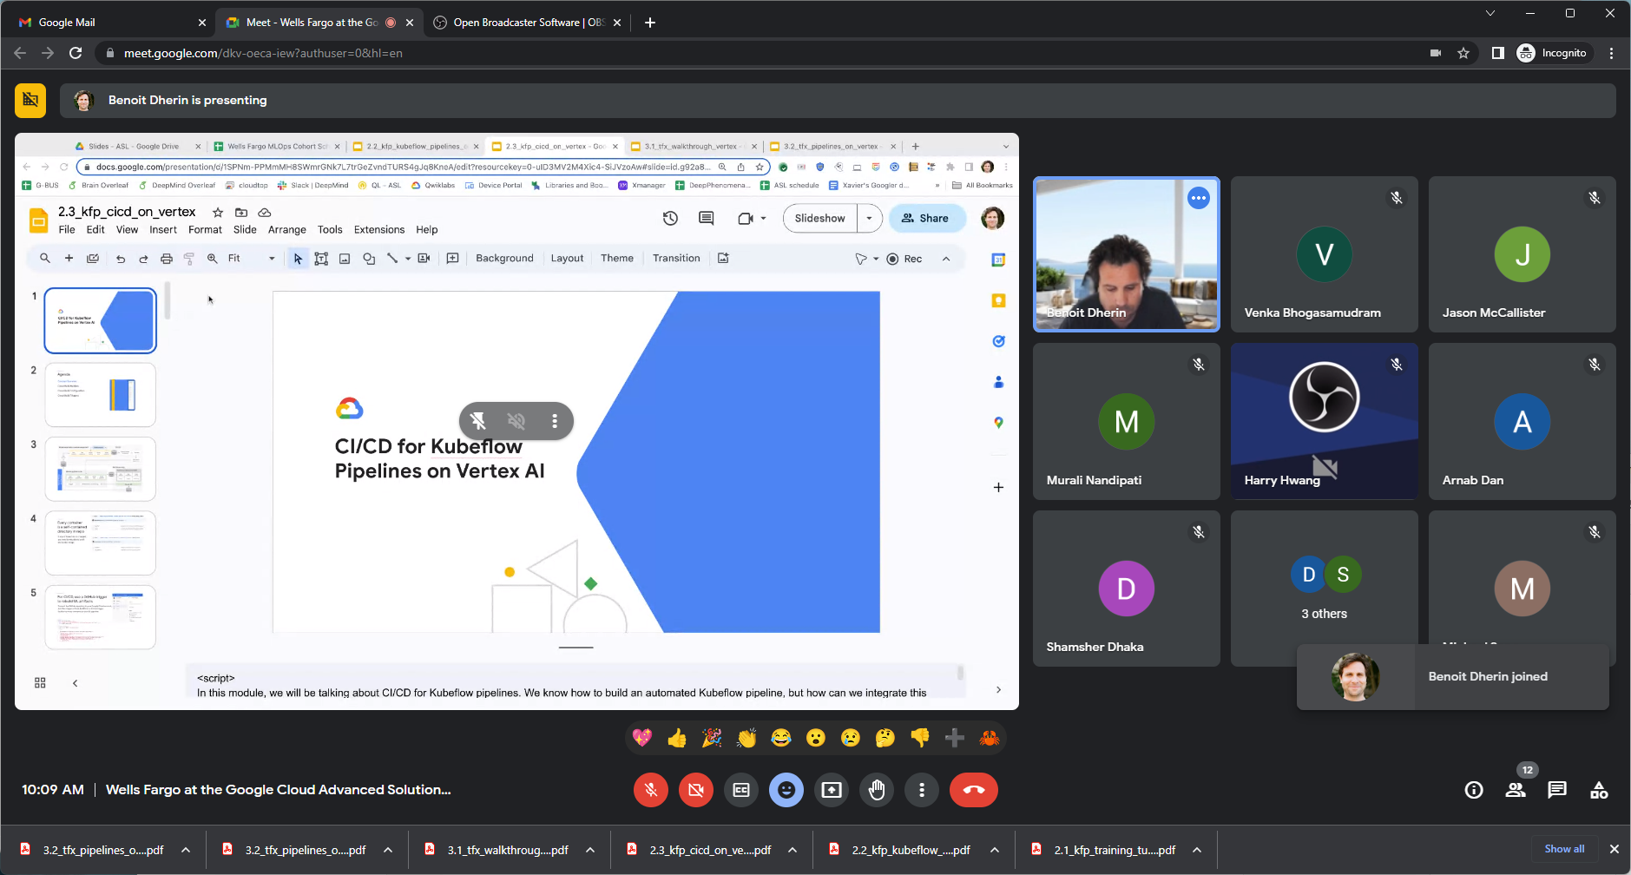

All artifacts to run pipeline..

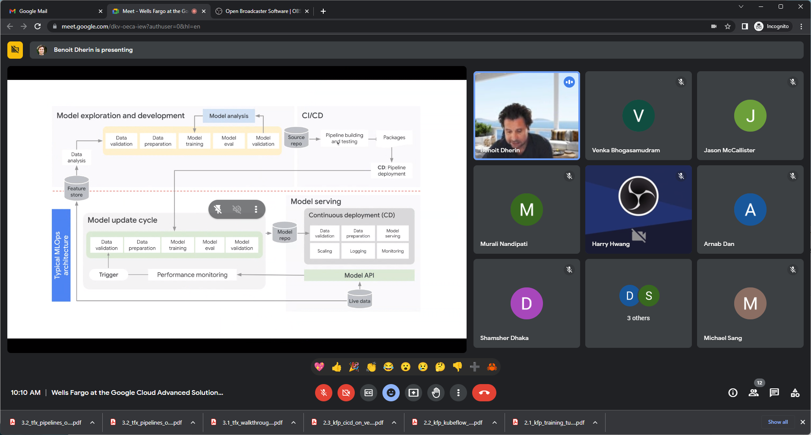

Full MLOPS stack above.

Now, integrate upper part of diagram.. in next slides..

Containers – key for KFP pipeline and for CI/CD process.

Launch cloud build tool using container.

Write cloud build yaml file = containing the configuration steps.

Cloud build – to automate pipeline – is easier/simpler than KFP/Cloud Composer.

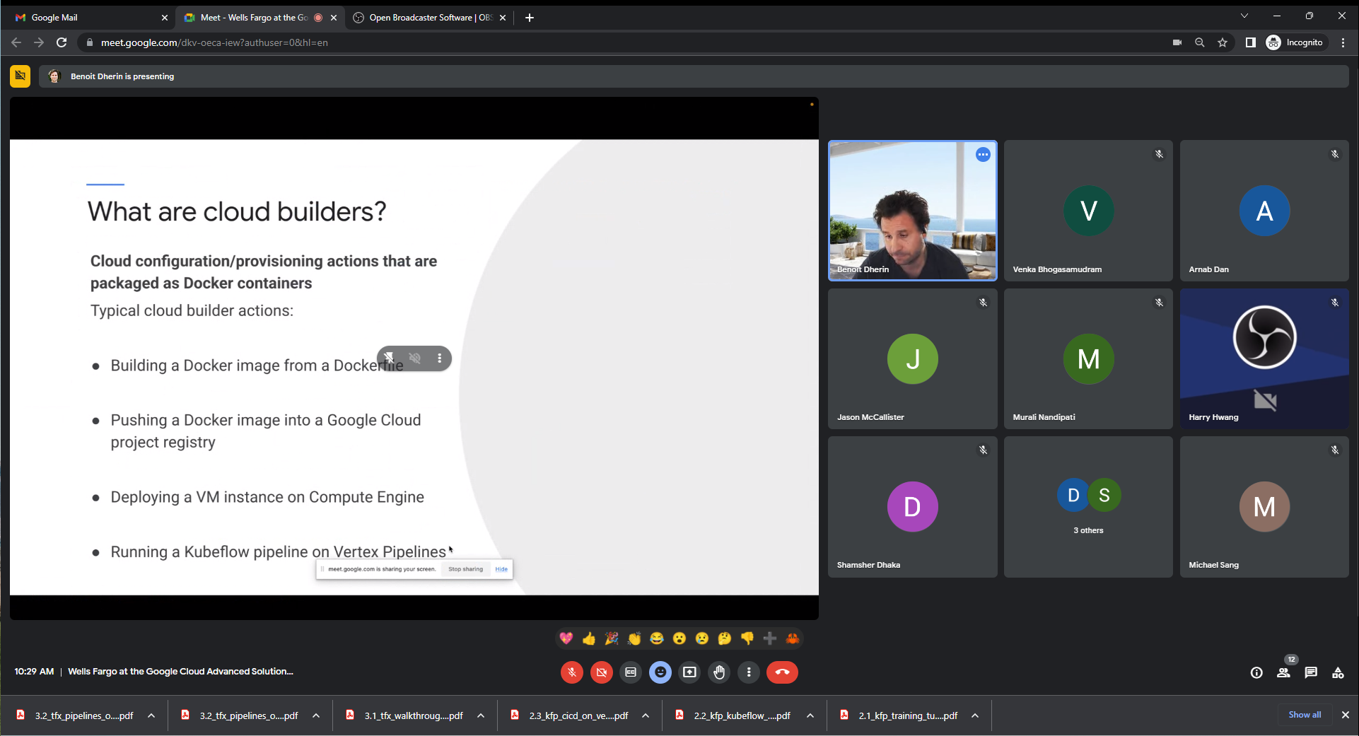

Every pipeline write cloud build.

Cloud build – infrastructure.. build infrast for software to run and run it.

Cloudbuild.yaml – no need to hardcode anything in there..build/code deployed to right vm.. etc.

Build a Docker image using Cloud Build.

Makefile install – to compile code – old technology – Cloudbuild.yaml analog to makefile.. install right things and right place and launch it.

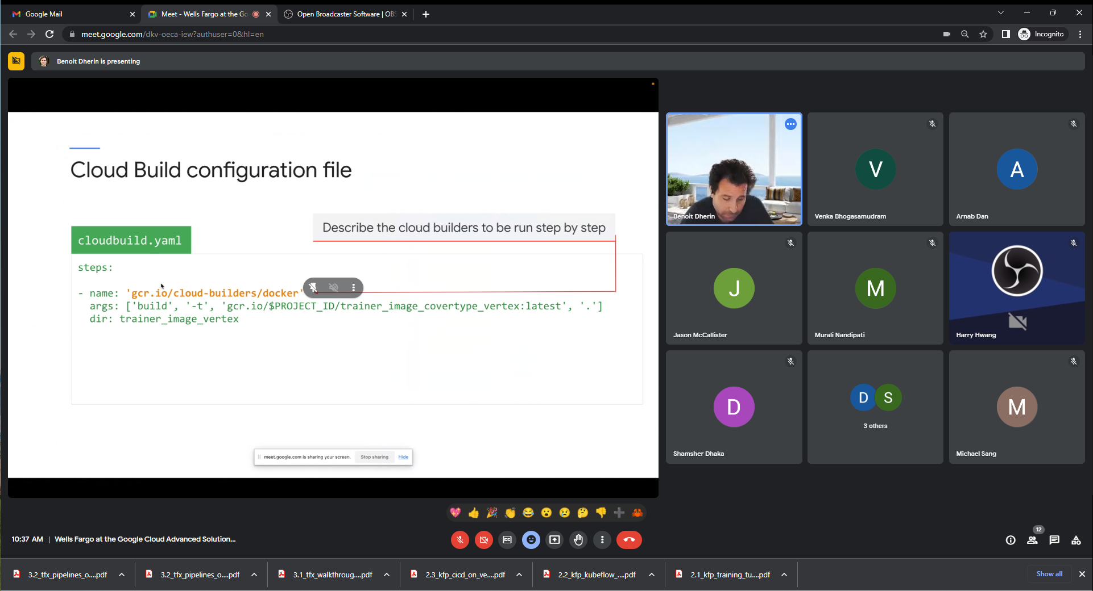

Docker container wrapping a docker command above

All cloud builders run on same node and sharing part of a file system through /workspace in File system of each of the containers.

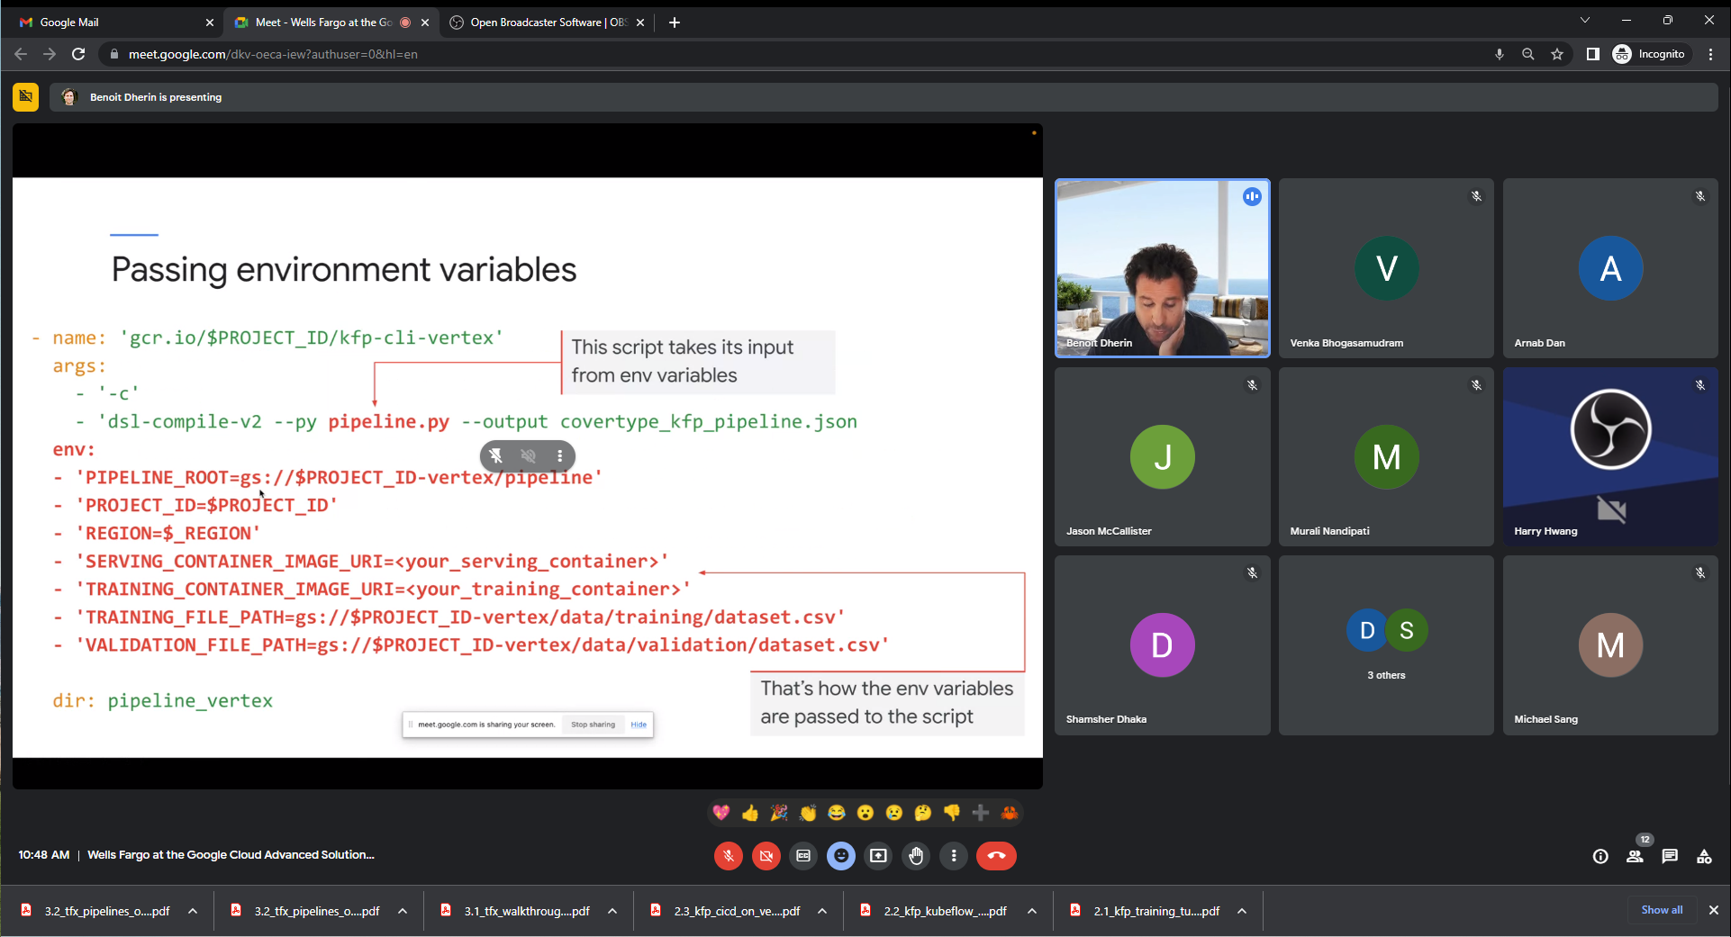

Pipeline.py get input from environment variables.